7.1.8 - Describe the Institutional efforts/initiatives in providing an inclusive environment i.e., tolerance and harmony towards cultural, regional, linguistic, communal socioeconomic and other diversities

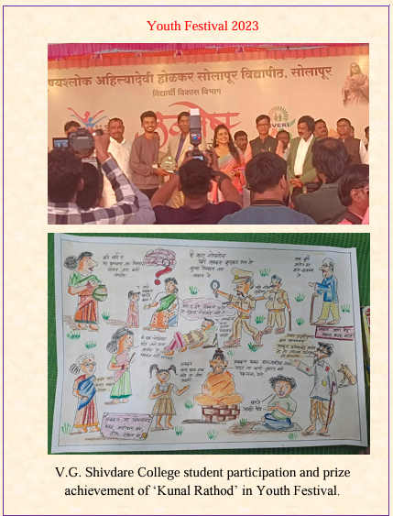

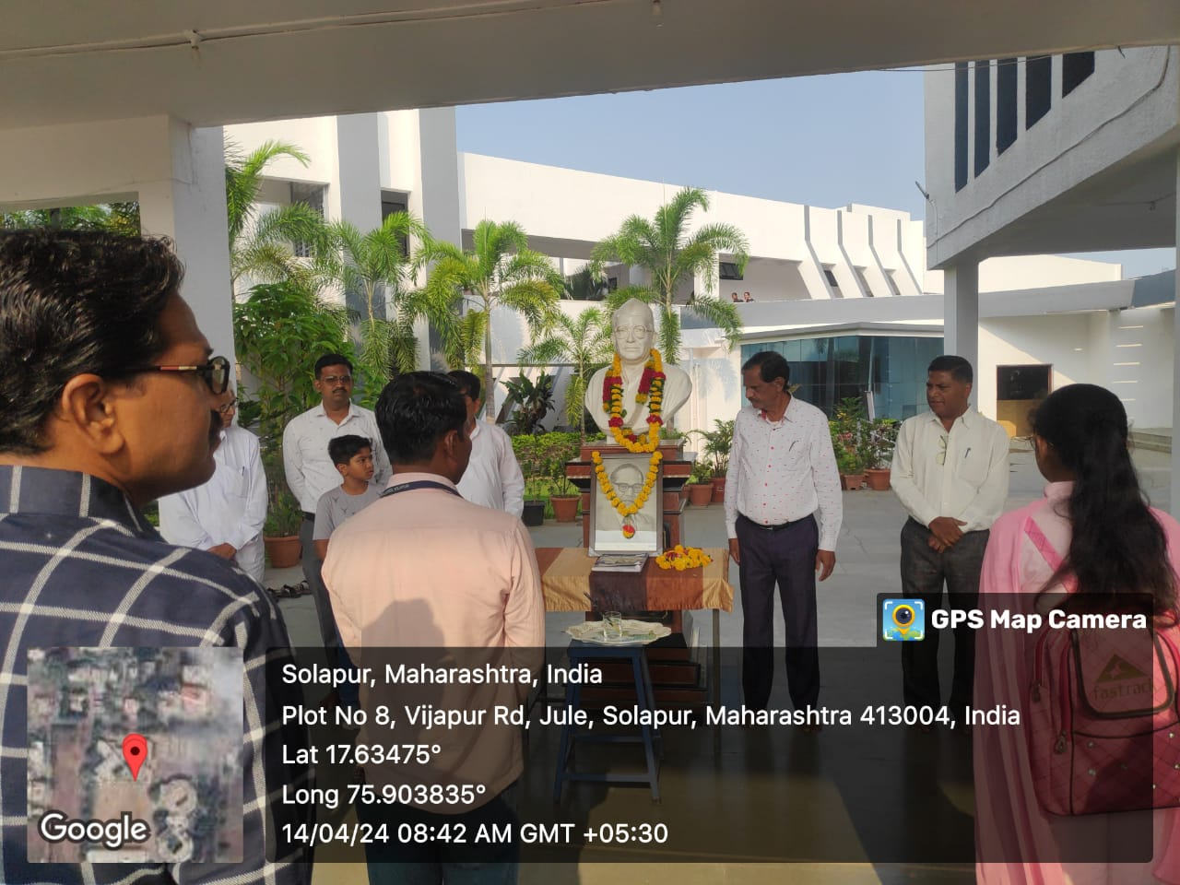
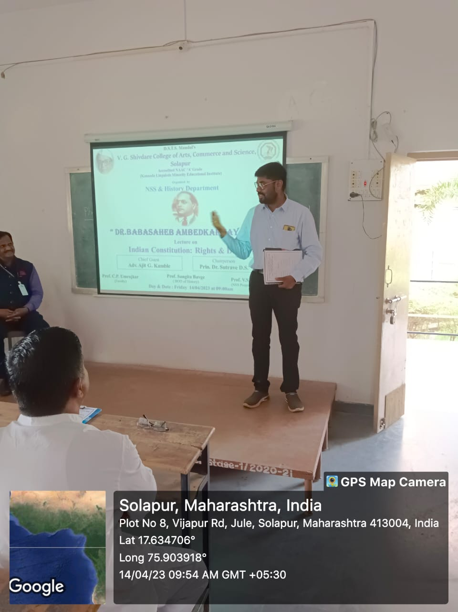
- Celebration of birth anniversary Dr.Baba Saheb Ambedker guest lecture Arrangment for the students

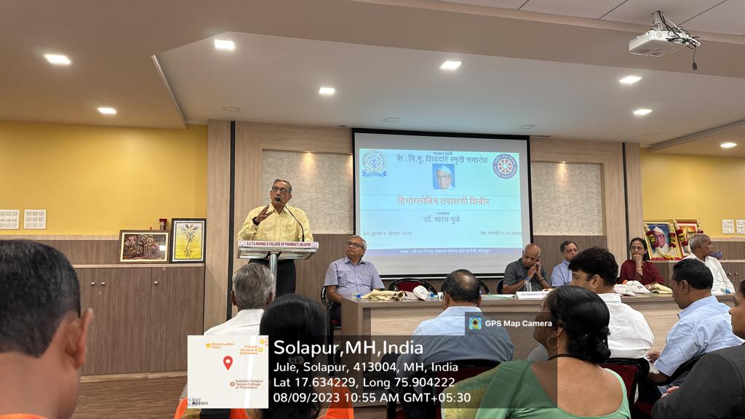
b)Haemoglobin and Thalassemia awareness check-up camp for girls

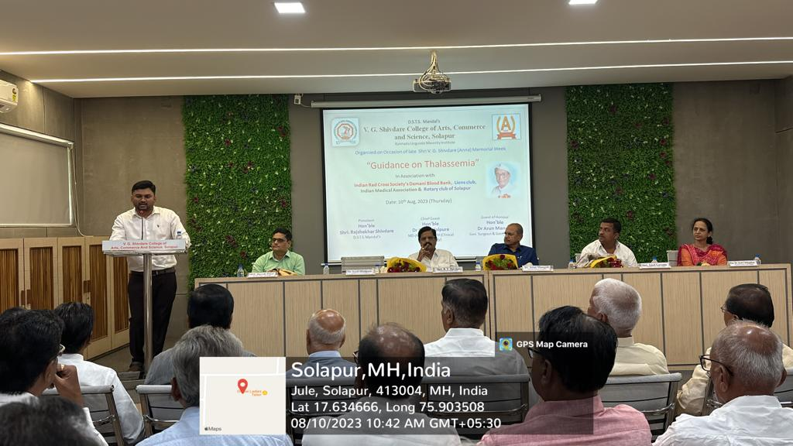
- Haemoglobin and Thalassemia awareness check-up camp for girls
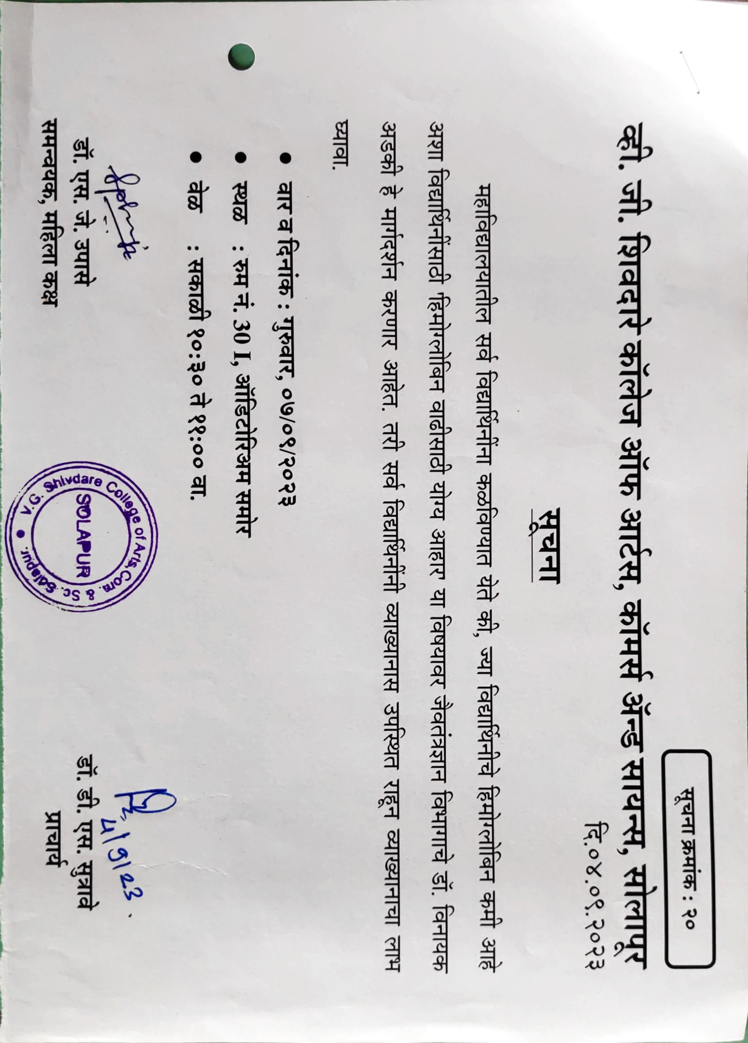
- Principal Notice Haemoglobin and Thalassemia awareness check-up camp

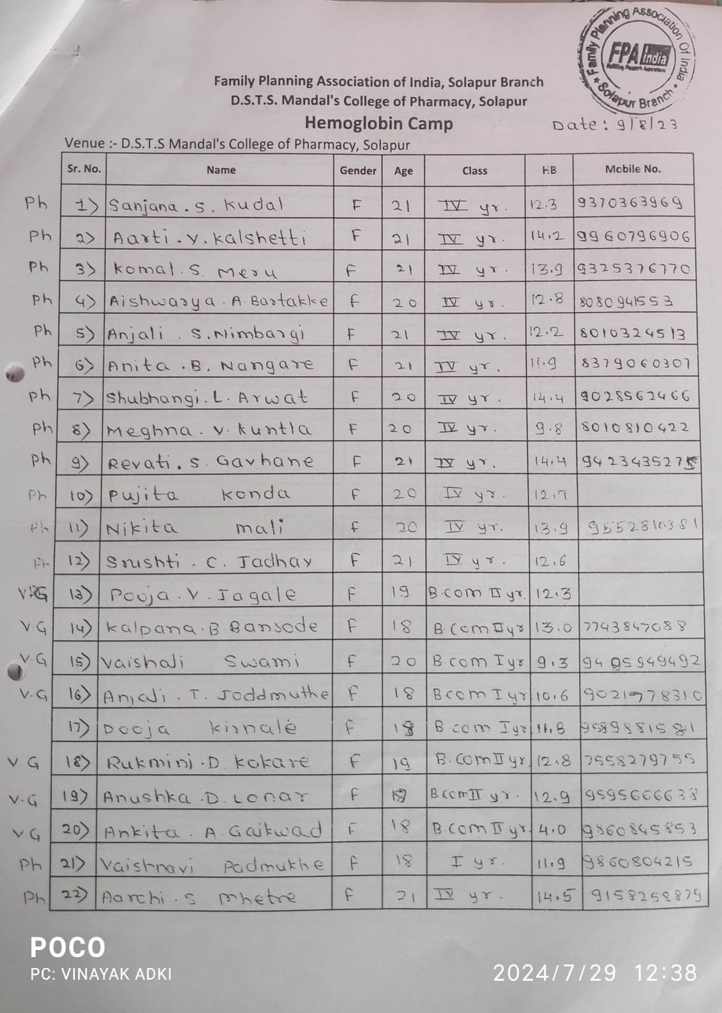
- List of Students enrolled for Check up

- Self defence Program For girls- 2023

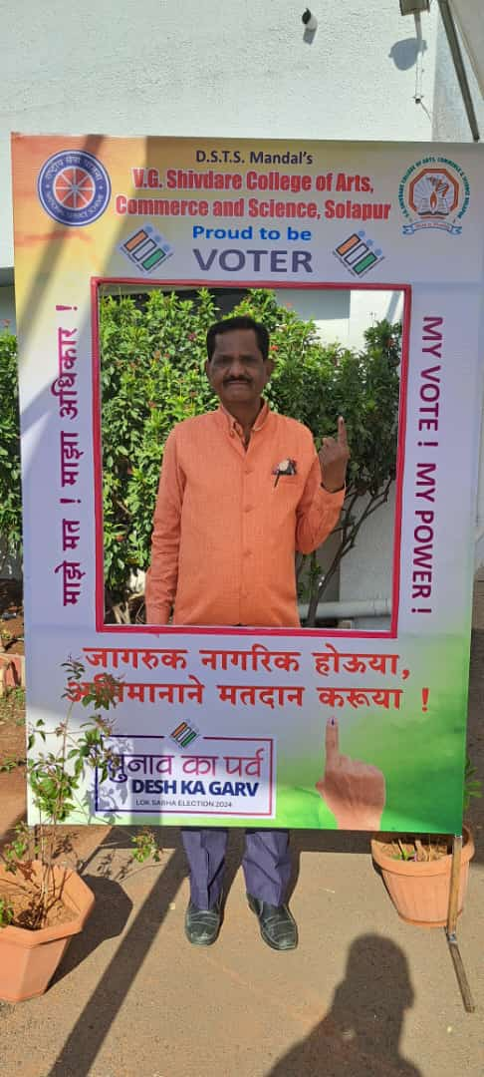
- Principal Dr. Sutrave D.S in ‘Voters awareness programm’

7.1.1 - Measures initiated by the Institution for the promotion of gender equity during the
year
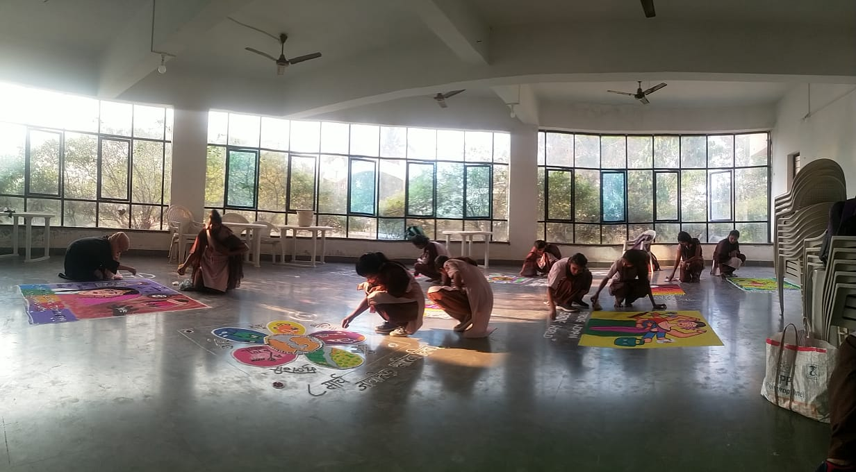
- Rangoli and Mehndi art competion on topic women
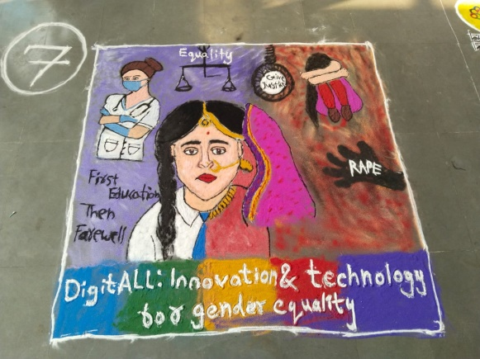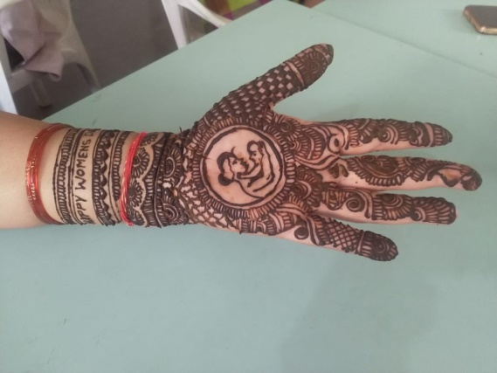

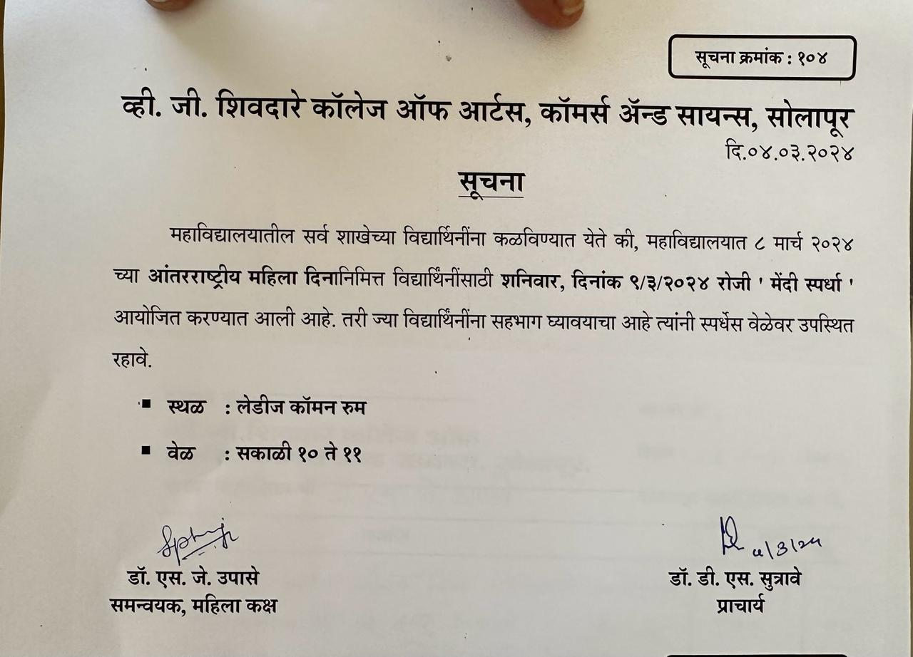
- Principal notice for international womens day celebration

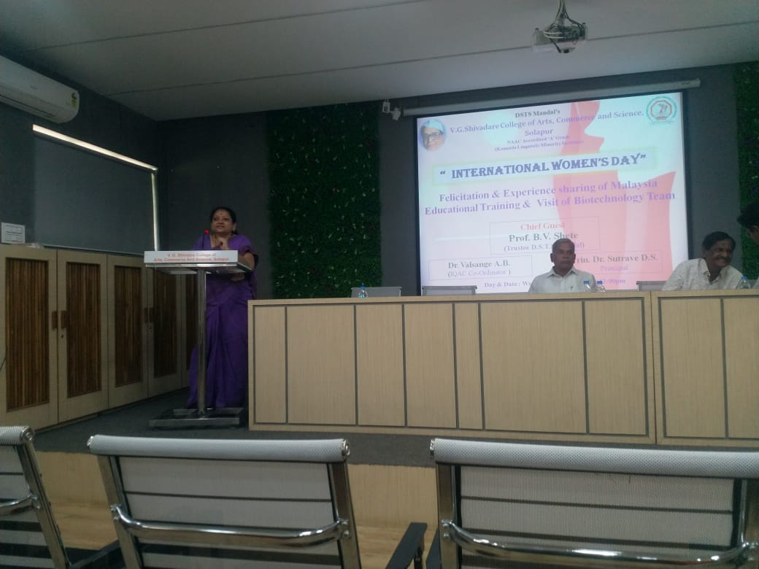
d)8th March 2023-Department of Biotechnology
International Womens day celebtration Chief guest Mr. B.V Shete sir (Trustee D.S.T.S Mandal)

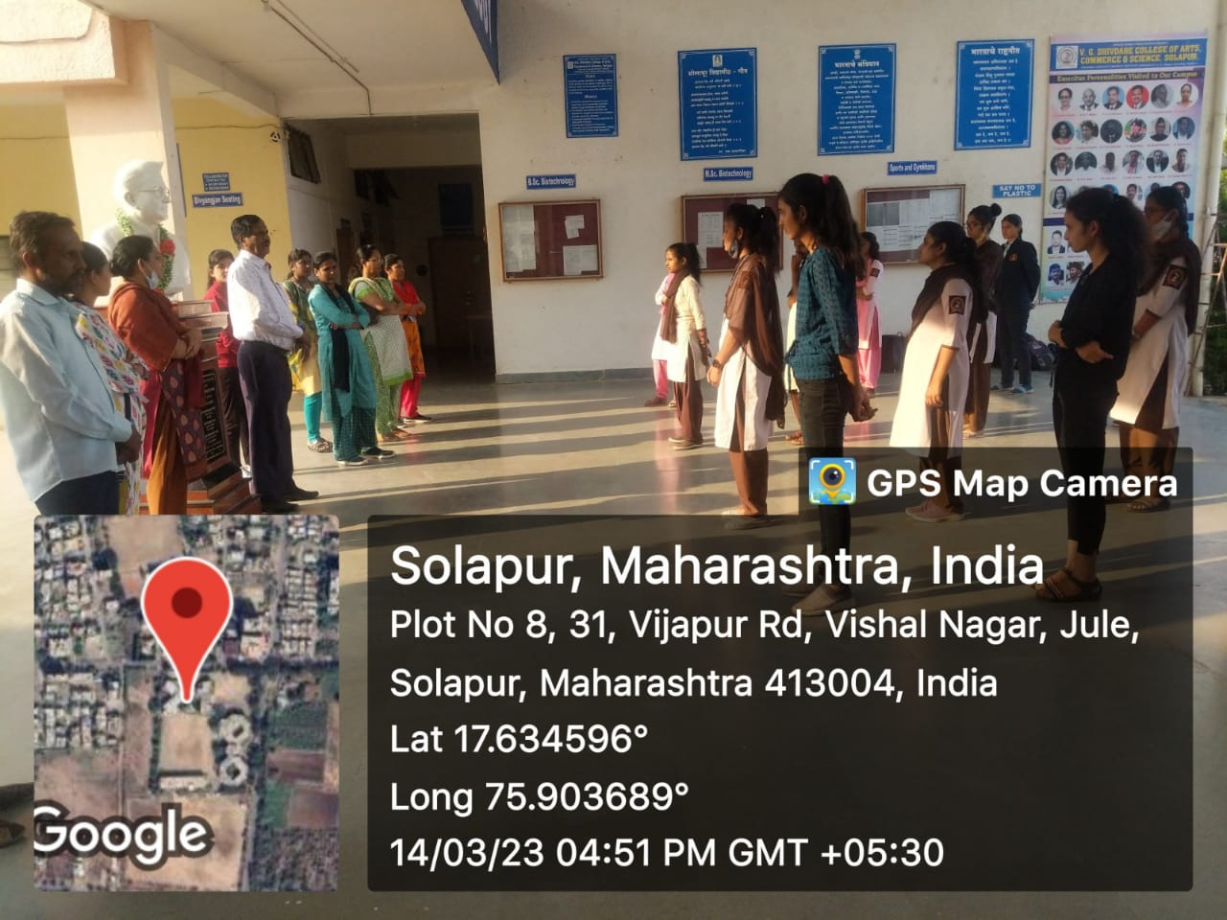
e) Self defence Program For girls- 2023

a)Solid waste management through Slopur Municipal Ghantha Gadi
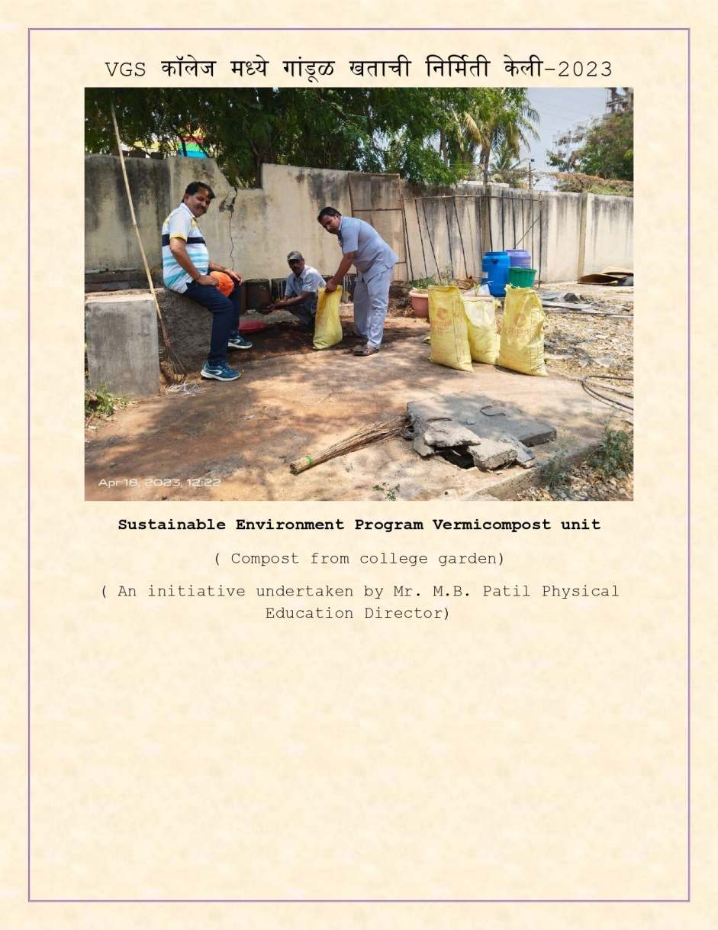
b) College started producing vermicost unit of oganic fertilizer for plants present in college campous tomanage some solid waste

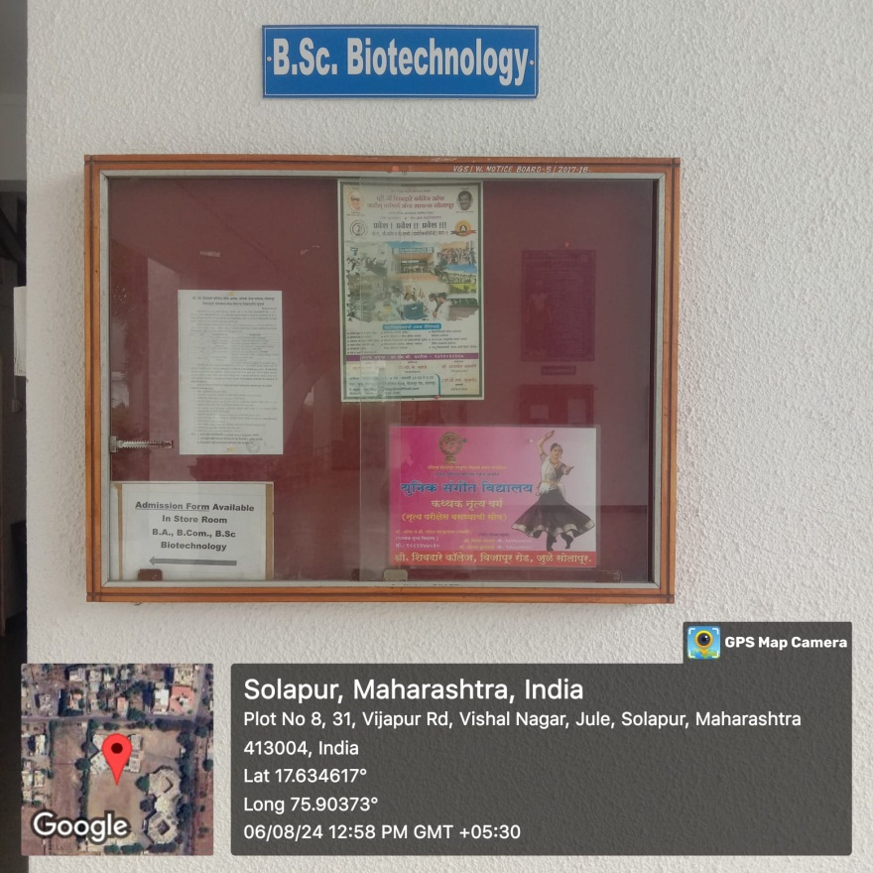
(i)
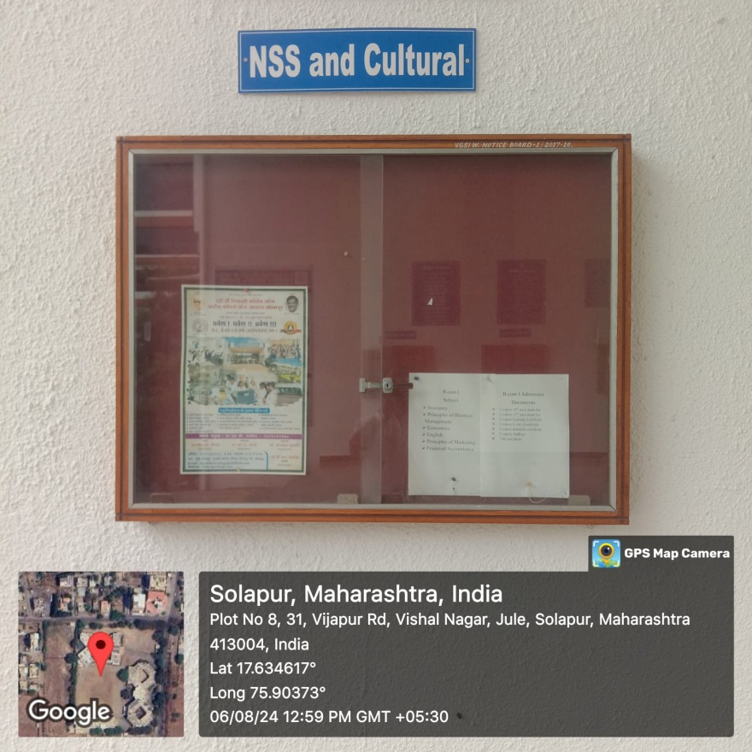
(ii)
C) Image (i) &(ii) respectivly indiactes every department wise display board for studnets

7.1.8Describe the intitutional effort /initiatives in providing an inclusive environment i.e. tolerance and harmony to wors culural ,regional, Linguistic communal socioeconomics and other deversities

7.1.9 Sensitization of students and employes of the institution to the constitutional obligation Values, rights duties an responsibilities of citizens
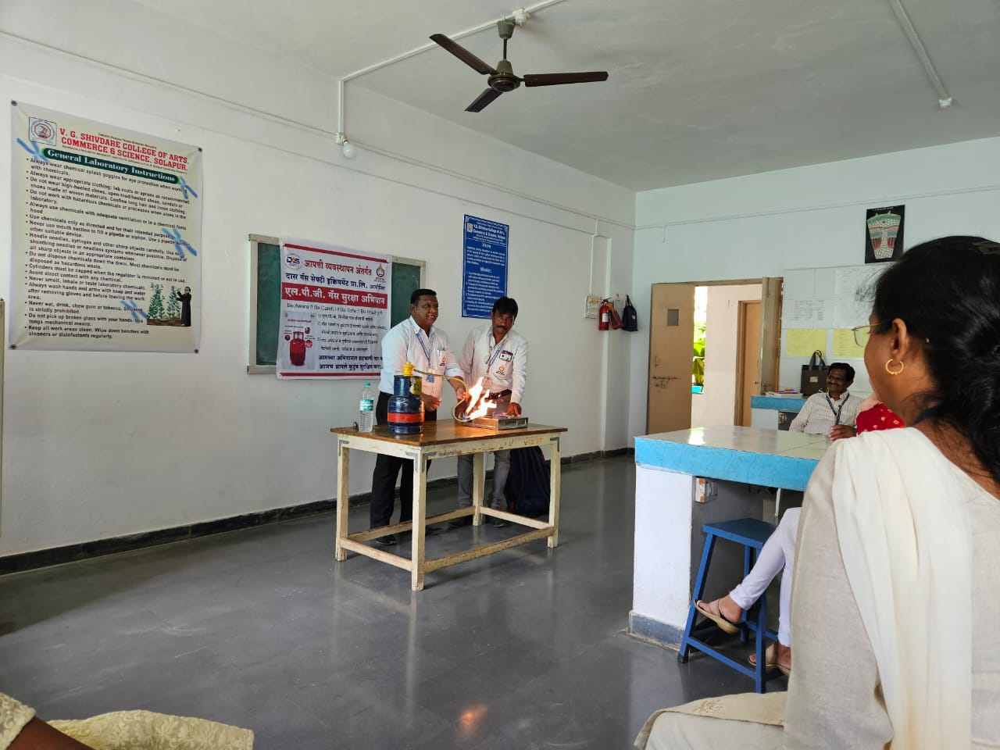
- Disaster Management Program - 2023 Collaborative Activity in association with
Das Gas Safety Equipment Pvt. Ltd.

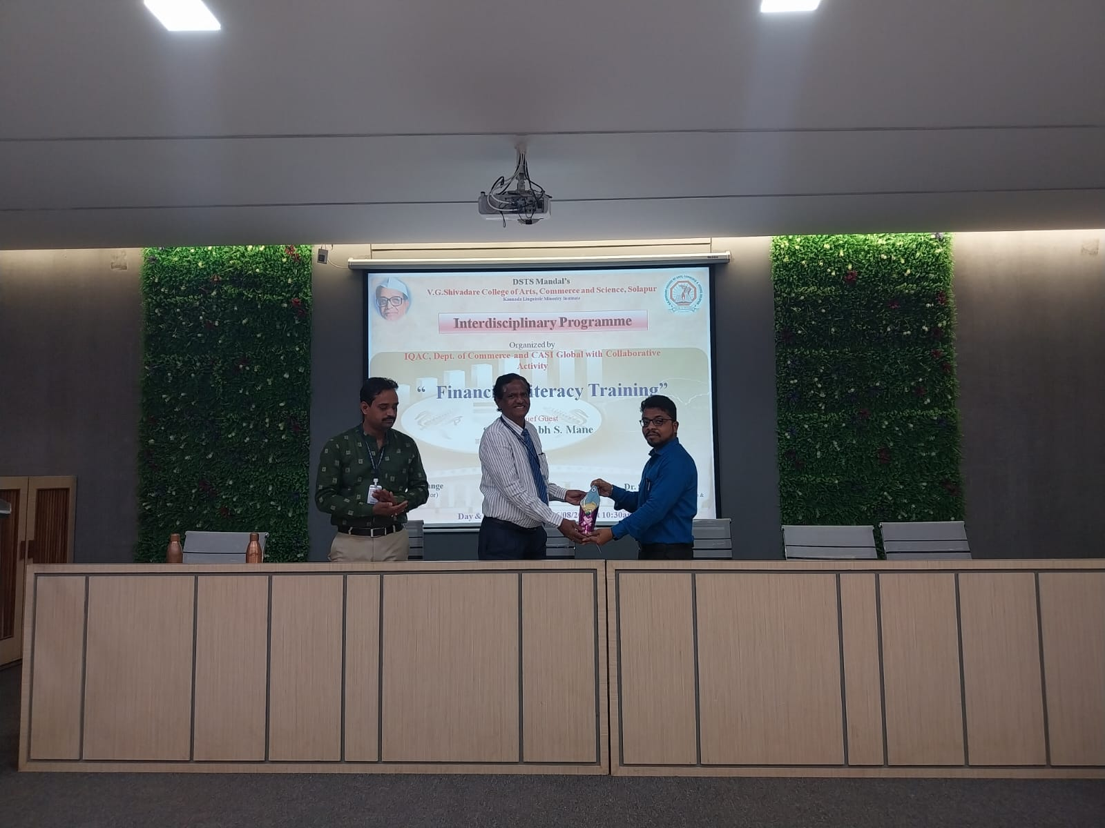
- IQAC, Dept. of Commerce and CASI Global with Collaborative Activity
“ Financial Lituracy Training”

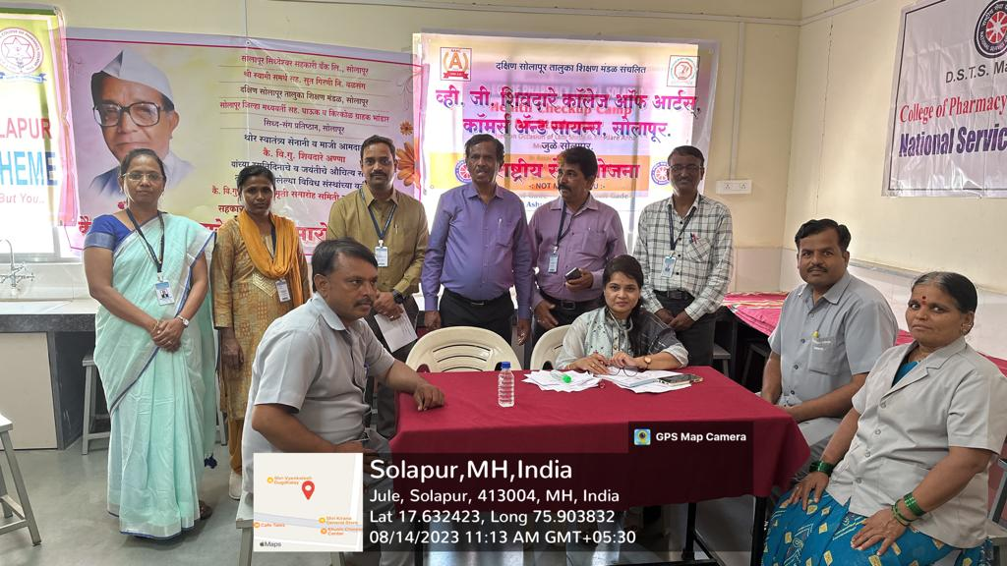
- Health checkup camp For Teaching and Non Teaching Staff members
-

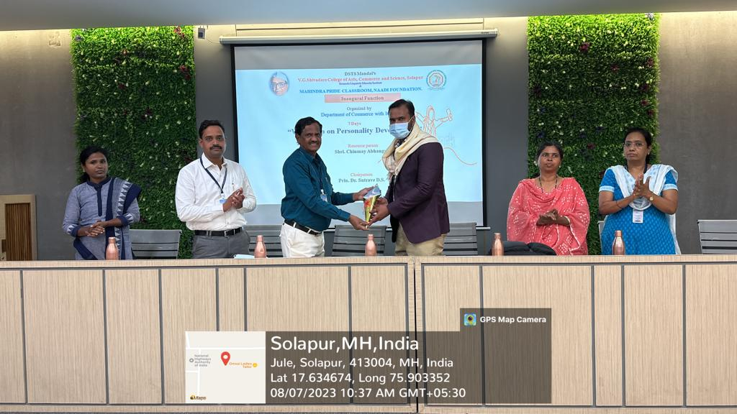
d)7 Days Workshop on Personality Development

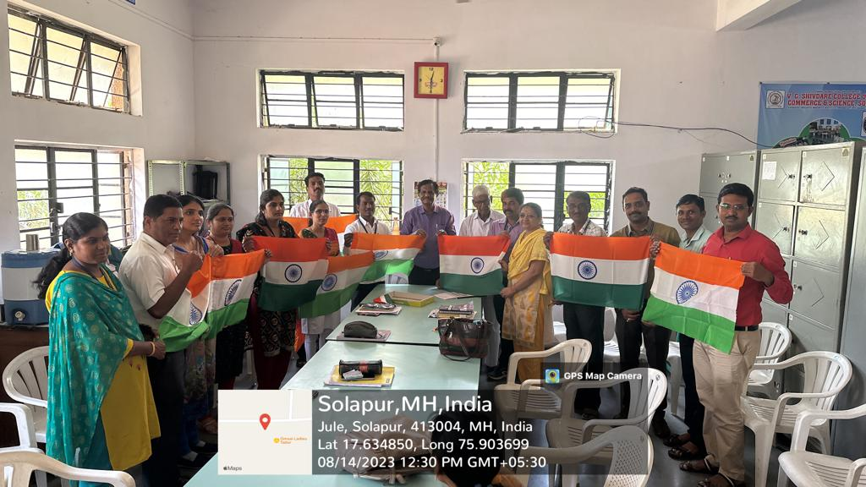
e)Har Ghar Tiranga Program 2023
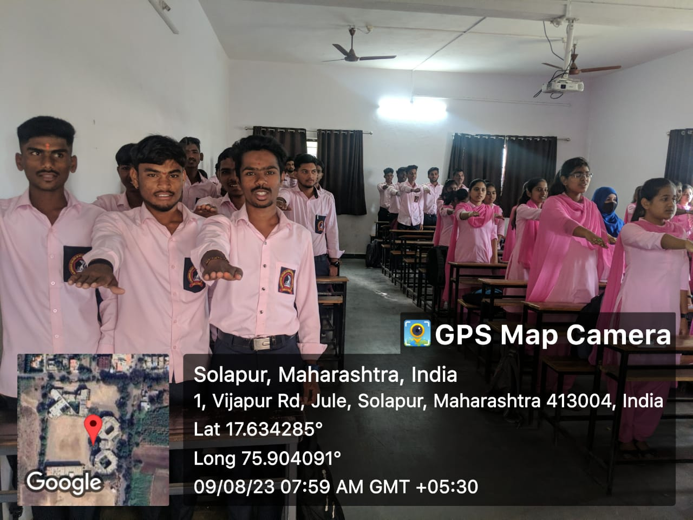

f) Meri Matti Mera Desh Program Pledge

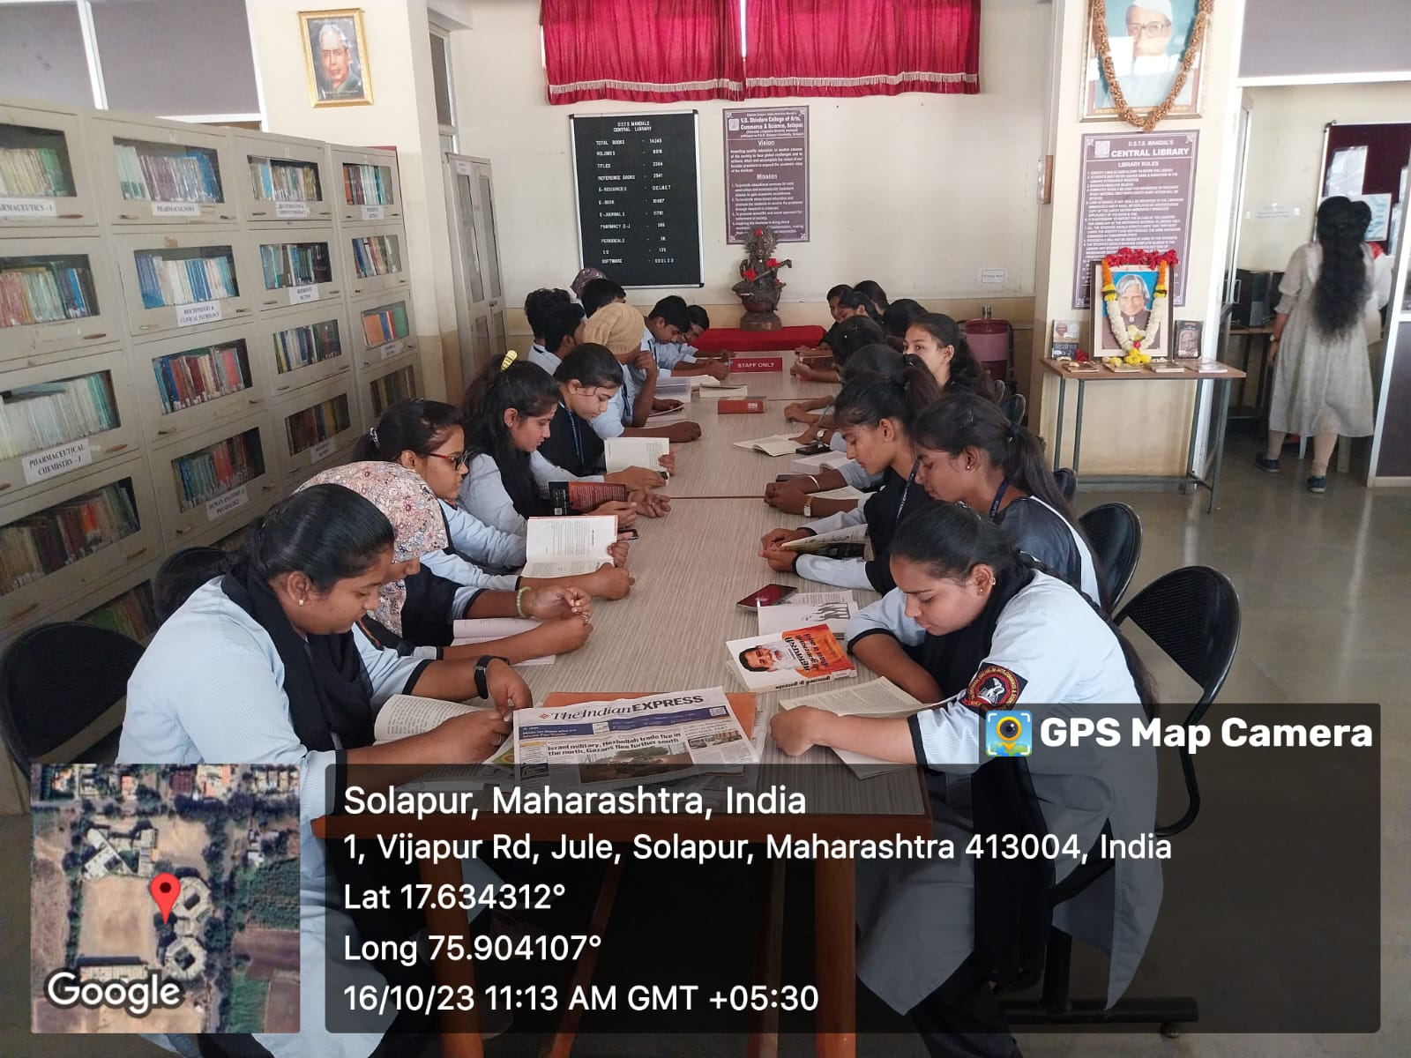
g) Dr.A.P.J Abdul Kalam Birth Anniversary day celebration
वाचन प्रेरना दिन
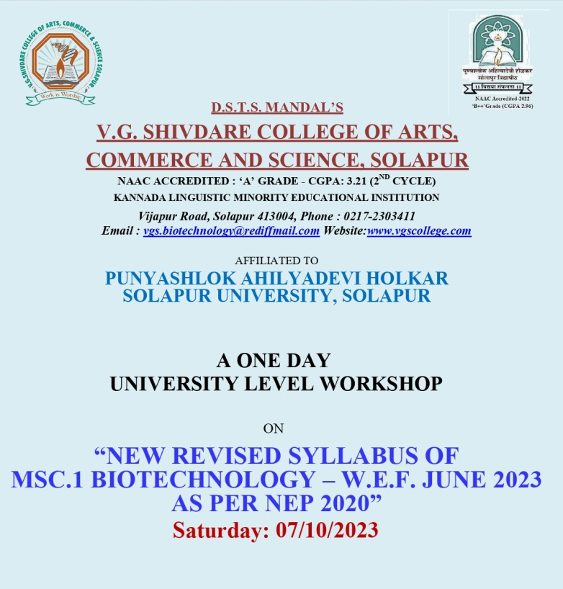
h)One day Workshop on NEP for M.Sc- I Biotechnology

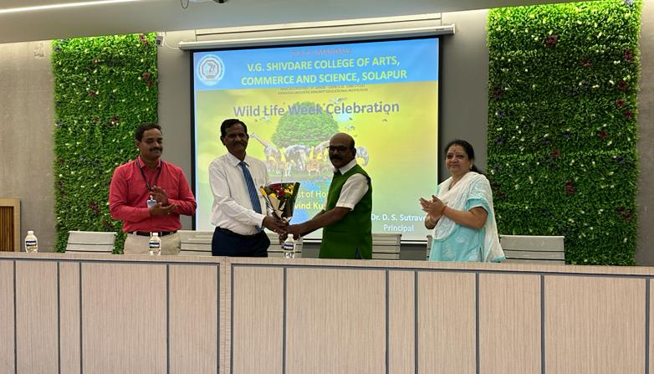

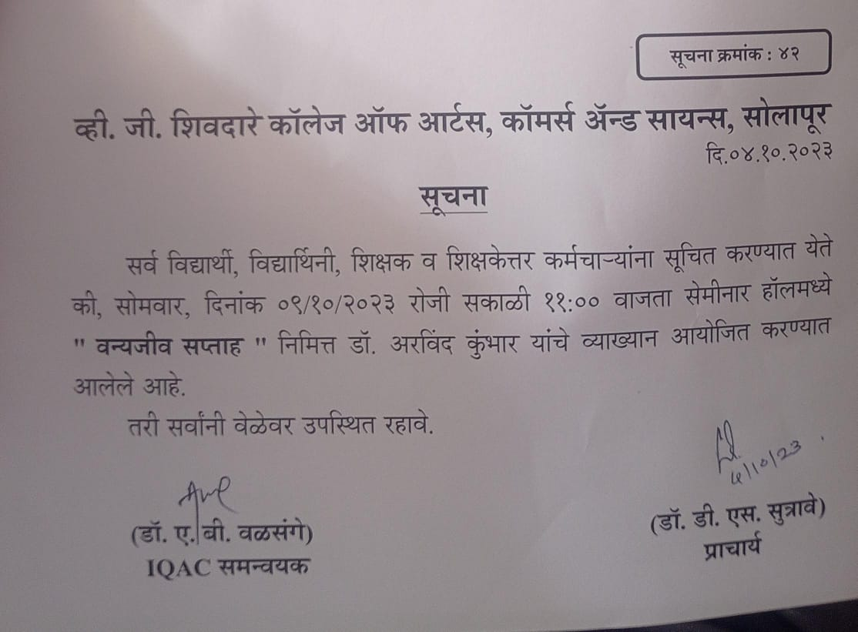
i)Wild Life Week Celebration 2023
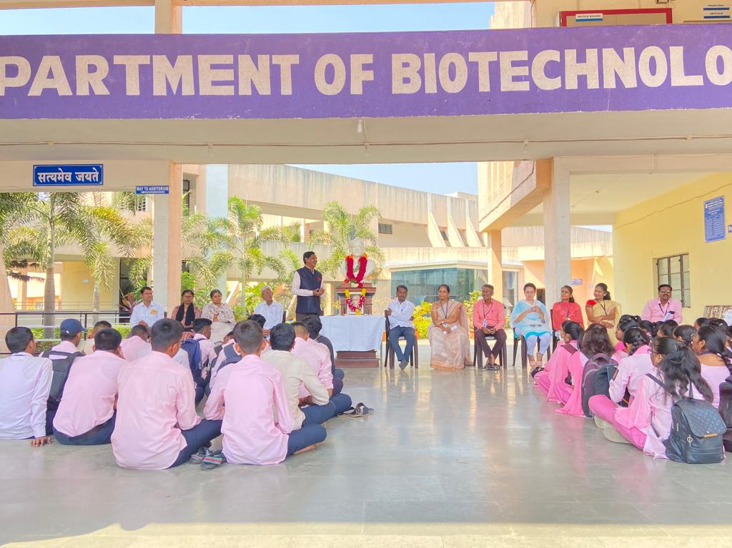
j) Marathi bhashya Din Celebration for by Marathi Department
k) Self Defence Training on Women’s Day

7.1.11 The Intitution hasaprescribed code of conduct for students ,teaches , administration
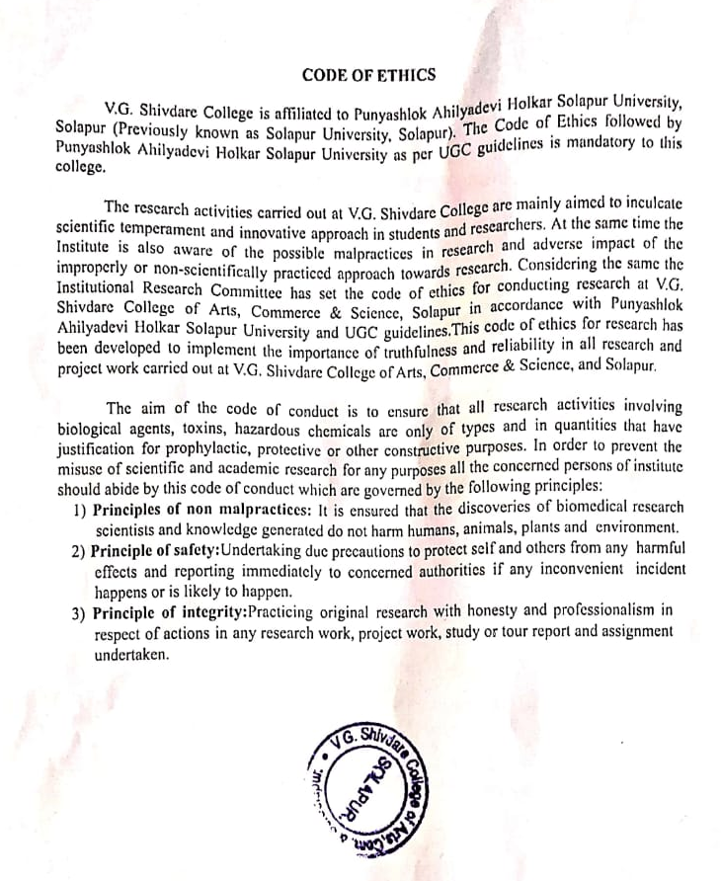

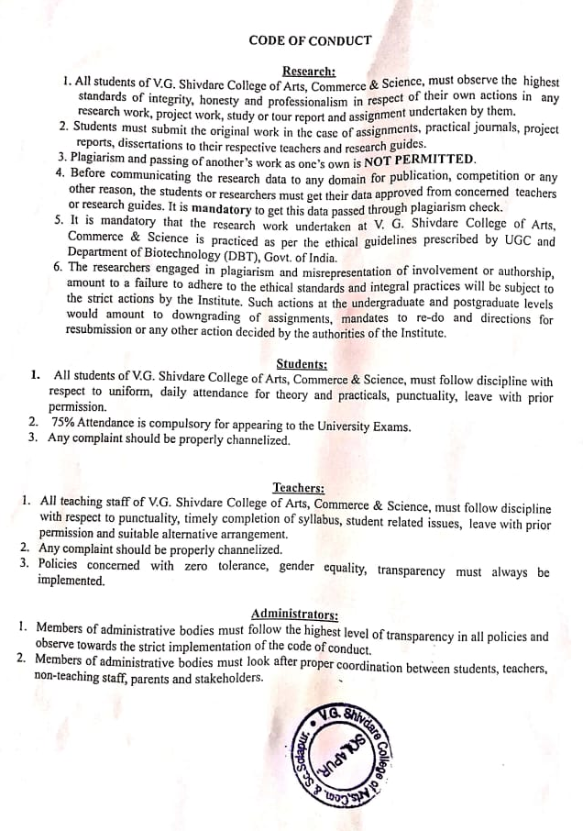

7.1.11 Intitution celebrates/ organises national and international commemorative days , events and festivals
a) International Women’s Day
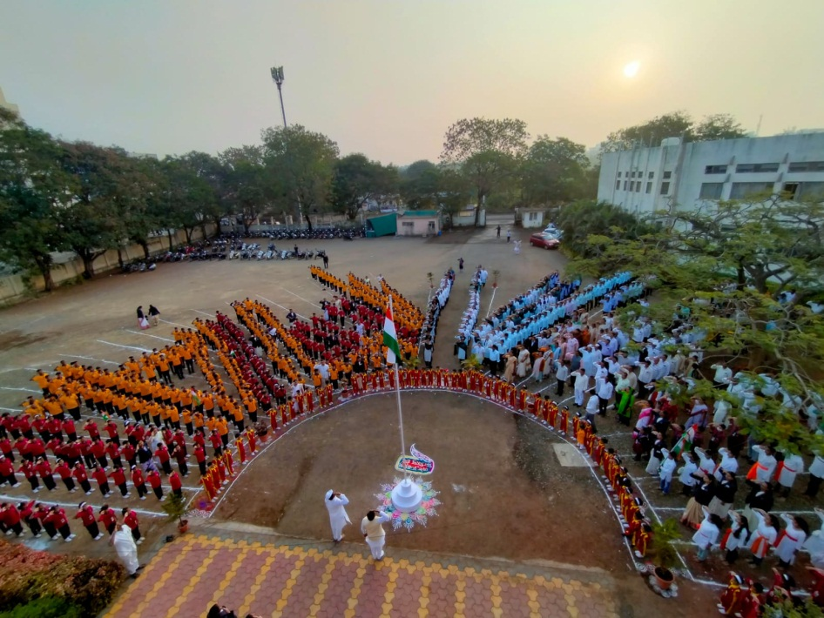

- Republic day celebration

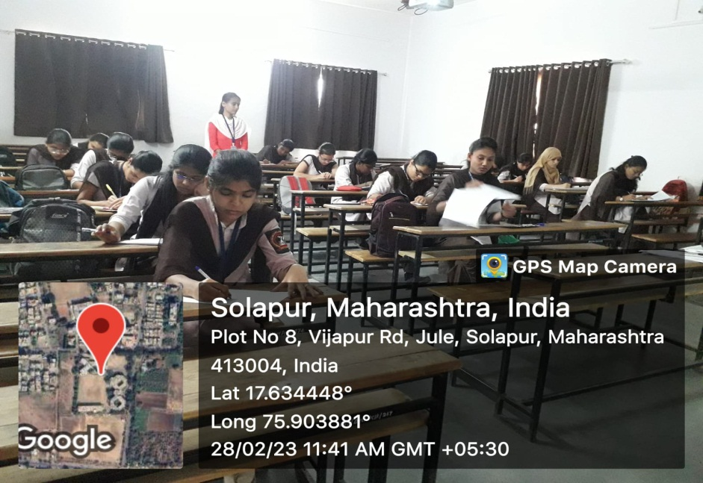
d)Science Day 2023 celebration with Guest Lecture and Essay Competition
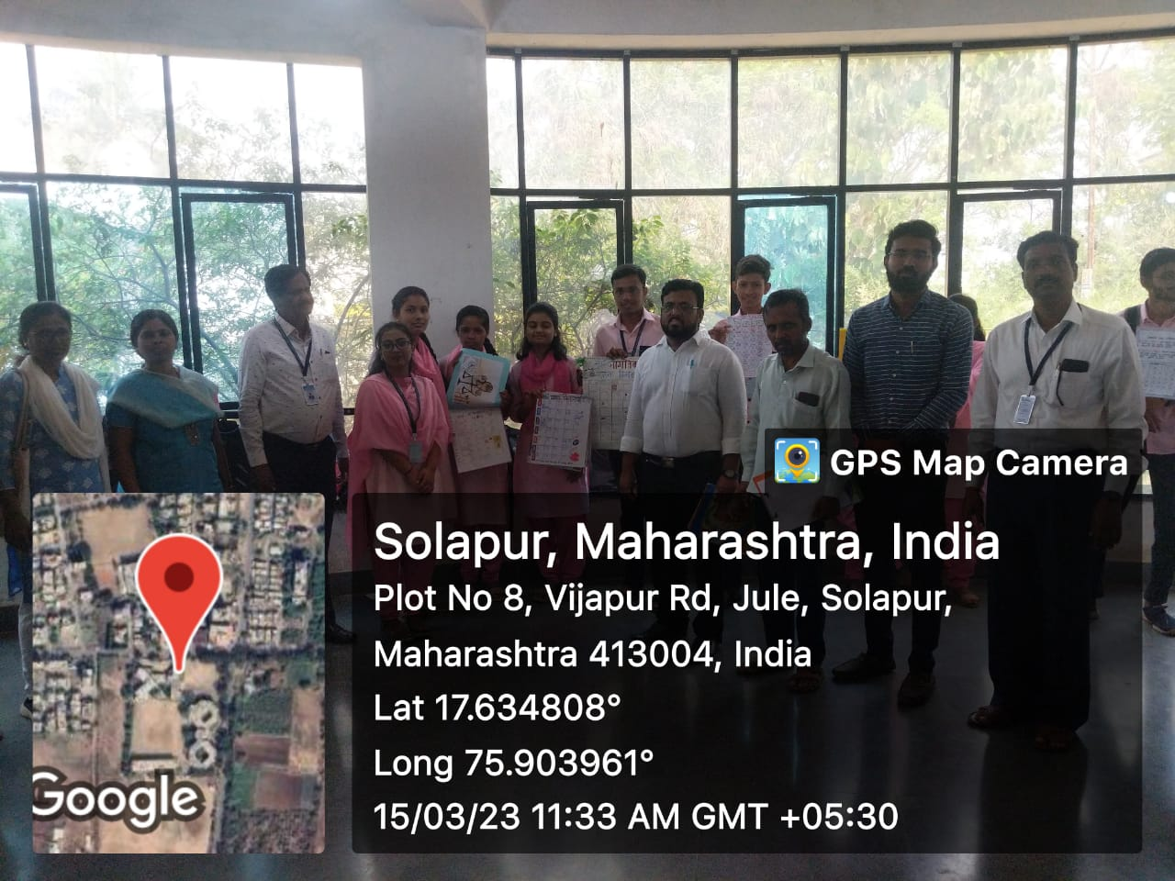
e)World Consumer Day Calendar Competition
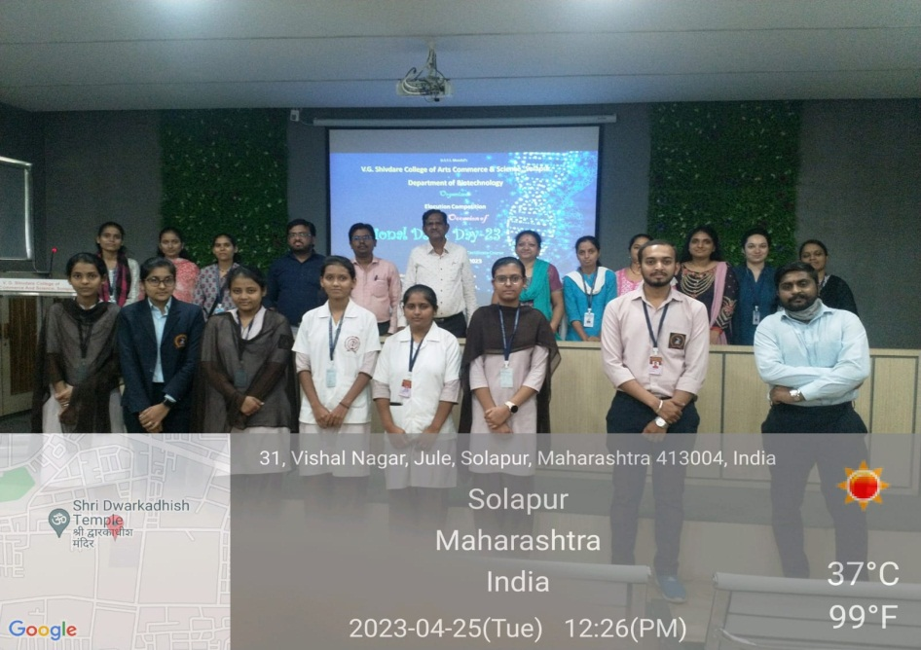
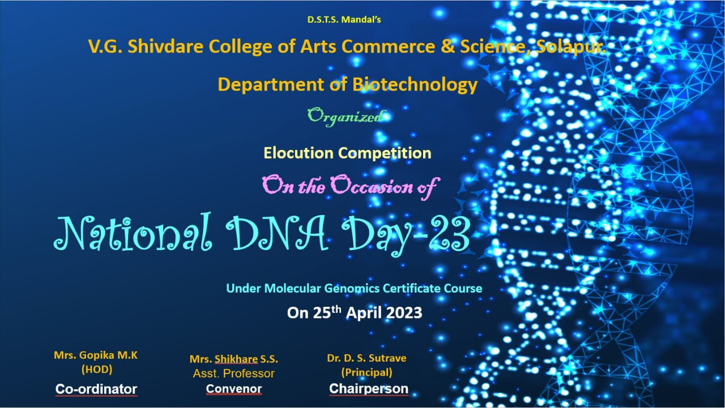

f) National DNA Day celebrated by department of biotechnology
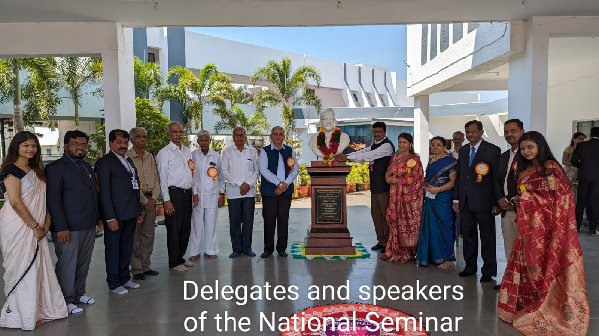
g) National Seminar on Tpoic ‘Cutting edges in research’ by department of biotechnology

