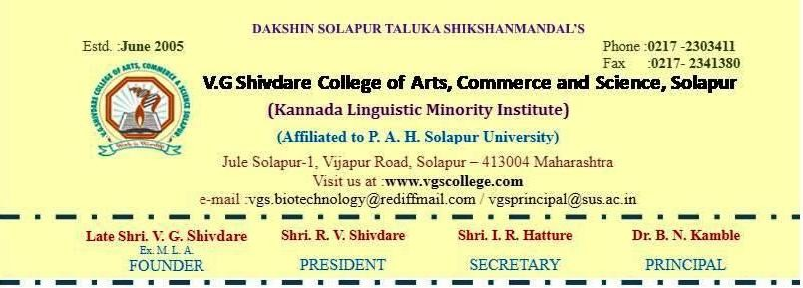



Audit Report on Environment and Energy – 2023-24

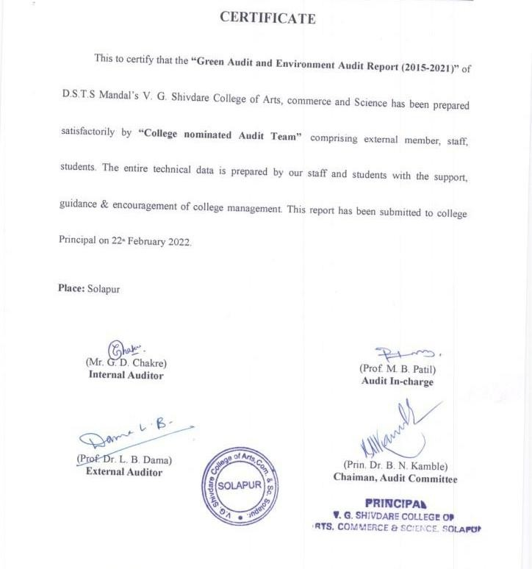

CONTENTS

Sr.  No | Particulars | Page No
1 | Introduction | 4
2 | Objectives | 5
3 | Auditing Committee | 6
4 | Methodology | 7
5 | Green Audit | 8
6 | Water Audit | 17
7 | Environment Audit | 20
8 | Energy Audit | 21
9 | Green Campus Initiatives | 28
10 | Beyond the campus environment promotion activities | 37

Introduction

The world in the 21st century is facing many challenges related to the environment. On one hand the world is developing at an alarming rate while on the other hand the destruction of natural resources is going on. That means the world's present development path is not sustainable. Efforts to meet the needs of a growing population in an interconnected but unequal and human-dominated world are ignoring the Earth’s essential life-support systems. Today, the human society is facing severe environmental problems like climate change, greenhouse effect, energy crisis, depletion of natural resources, biodiversity loss, pollution of air, water, soil, etc. The ever increasing population and changing lifestyles are increasing the severity of the environmental problems. The time has come to protect the natural environment through precise efforts. At the same time sustainable development through higher education provides a pivotal role in nation building. Sustainable development remains barely a significant social, economic or environmental challenge for any country. Though teaching and learning must begin to reflect environmental issues, there is an emerging consensus that institutions must also model sustainable practices. Such education contributes strongly to sustainable development by training and expanding young minds in researching solutions to the environmental challenges. After graduation the students become leaders of tomorrow and get dispersed from the world of higher education into their specific career. In doing so, they take with them the green practices and approaches they were involved with at their institution. Eco-campus or Ecological Campus has its meaning in itself. The meaning of eco-campus has been expressed in its targets and objectives. By all means, eco-campus means “environmental sustainability within the college”. College is a center for generating education; Moreover, it is also a research center where the students and teachers are attempting to develop the best strategy for achieving their purposes. Due to this reason, the development of eco-campus has been pointed out and established recently. Eco-campus concept mainly focuses on the efficient uses of energy and water; minimize waste generation or pollution and also economic efficiency.

Objectives:

The main aim of the college campus is to reduce anthropogenic activity on the environment for sustainable development. The college promotes environment awareness among all stakeholders by involving in activities. The audit report on the environment and energy of college has been taken with the following objectives.
- To introspect the practices that have an impact on environmental degradation.
- To take a review on eco-friendly processes in campus to reduce ‘Carbon Footprint’ on nature.
- To evaluate the promotion for proper disposal of solid waste within campus for effective recycling and to educate students on anti-littering strategies.
- To recognize the important role our faculty and students play in maintaining and sustaining earth’s natural resources.
- To understand initiation and implement strategies for achieving an eco-friendly campus.
- To evaluate the energy consumption and alternative energy sources in college campus..
- To ensure the promotional measure for water recycling and effective utilization in college campus.
- To undertake research that seeks to promote research in flora, fauna, water harvesting, alternative energy sources, vermicomposting and solar cell etc.

AUDITING COMMITTEE

Core-committee
Name | Members
Prin. Dr. B. N. Kamble | Chairman
Dr. L. B. Dama | External auditor
Mr. G. D. Chakre | Internal auditor
Mr. M. B. Patil | In-charge
Green Audit Sub-Committee
Dr. A. B. Valsange | Coordinator
Mr. S. S. Ghongade | Member
Ms. R. D. Potdar | Member
Mr. S. S. Bake | Student
Mr. M. S. Mhetre | Student
Environmental Audit Sub-Committee
Dr. R. S. Dhanave | Coordinator
Mr. L.R. Gote | Member
Ms. V. T. Rathod | Student
Mr. S. S. Fundipalle | Student
Ms. S. S. Birajdar | Student
Mr. V. S. Bagale | Student

Methodology:

Auditing serves as a tool to document and evaluate performance of units in an organization or system for the purpose of safeguarding the environment through set procedures, protocols and criteria. The college took the initiative to undertake environmental and energy audits through the use of expertise available with – Staff, Students & stakeholders. In order to meet our objectives, this audit report comprises green audit, energy audit, environment audit and water audit. The audit is done in combination of physical inspection with a review of relevant documentation and interviews with various stakeholders.
- Review of the Documentation: For the purpose of this audit the Green Policy of the institute was reviewed, and was also considered.
- Interviews: Interviews were conducted with the Principal, and also faculties and students.
- Physical Inspection: The audit team was in the college to inspect the campus.
Scope - Educational institutes are like mini communities with diverse groups such as Staff, students, visitors etc. All these groups and their activities, Laboratories and support services within campus Shows the impact on environment and energy utilization. In order to minimize our impact on natural resources there is always scope to devise actions & methods that ultimately support sustainable conservation.
The following action plan is considered while going to various audits of college campus.
- Problems of environmental concern - The survey can be taken as part to understand the overall impact of college and its stakeholders on various components of the environment. The campus infrastructure, laboratories, support services and their operating procedures were analyzed for their impact on the environment. The temporal changes required by college to minimize these impacts were identified.
- Implementations of changes – The initiative taken by the college for implementing temporal changes for sustainable development within the campus were analyzed here.
- Post implementation review – The effectiveness of the implementation of eco-friendly approaches within college campus will be reviewed.

GREEN AUDIT
The college works with ‘Eco-mission for sustainable development’ embodies three basic principles of sustainable conservation ‘reduce, reuse and recycle’. The ultimate goal of our initiatives is to reduce ‘Carbon Footprint’ of individuals and the community as a whole.
The following things are considered under the Green Audit.
- Eco-friendly infrastructure
- Waste management system
- Water utilization and harvesting system
- Renewable energy source

Eco-friendly infrastructure –
The college has tried to maintain an eco-friendly approach at its campus in the view of following points.

Land Management –
The college land had a slope of about 2-3 meter naturally as well as it had no wall compound initially. So that rain water will flow on to roads and very little percolate in the ground, as a result underground water started drying during summer. The college surveyed the land, and used a cut and fill method to level the top area of open land. Not a single cm of material was borrowed from outside. This had saved money as well as reduced transportation resulting in reducing the emission of gasses like CO, CO2. The college had constructed the wall compound, as a result top soil is conserved now and not a single drop of rain water flows out of the campus.
College chalked out areas under buildings, areas for roads, areas for parking lots, playgrounds etc. The remaining area and campus boundaries were used by the college for plantation purposes. The shadows cost by plantation has resulted in reduction of radiation on ground, thus reducing temperature of campus. The college segregated traffic into vehicular and pedestrian. Vehicular traffic is allowed up to parking lots only reducing noise and air pollution. Trees along the boundaries also have helped in reducing noise generated from traffic on public roads.

Design and Detailing of Buildings –

Consideration of Climatic conditions – Solapur is a hot and dry area having a rainfall of average 55-65 cm. Presence of dust in the air is very high. Hot breeze flows from West to East almost eight months. North and South are found glare free and best suited for studies. All these conditions have been considered while constructing the college buildings.
Most of the laboratories and classrooms have been located along North and South. All parts of the building are naturally lighted and ventilated resulting in reduction in power consumption and use of materials like plastic required for constructing electrical points. To reduce heat and glare, the college provided narrow windows on the outer side and wider windows in walls abutting corridors. Corridors take in breeze from west and the flowing breeze through corridors has kept out floors always fresh. None of the areas are dark and stinking.
All external walls are cavity walls providing the best possible thermal insulation as well as helping in improving elevation treatment. Many of the internal walls are constructed using rat trap bonds. This is also cavity wall saving 30% material as well helps in cutting noise transmission. The use of concrete blocks is avoided as it absorbs heat and does not cool down faster as well as its life has been found lesser than of conventional bricks.
Rooftops – This is an area exposed to sun rays for the maximum period and most important in increasing the temperature inside the rooms. The college building is provided with a gentle slope to roofs cutting down thickness of brick bat coba generally provided to maintain proper slope. College buildings used brickbats only because brick is a product of mud, it is porous material and mostly a waste product available on construction sites and brick kilns at a comparatively low price. This has resulted in cutting down cost of materials and at the same time helped in reducing thermal radiation of roof top.
Flooring – College selected polished Tondur stone slabs. It is available in nearby places of college. Excavation, slicing and polishing are the only manufacturing processes during which gasses like CO, CO2 are not emitted. At the same time the waste of this material can be reused as lime. Thus, it is considered as an eco-friendly material. The use of ceramic tiles is restricted to certain prestigious areas only. Ceramic tile is not eco-friendly at the same time its wastage cannot be used. It keeps on adding debris on earth. The college has selected a smooth surface adding to ease of cleaning and reducing the use of chemicals for cleaning. To cope up with the need, the college had used acid resisting tiles in Biochemistry labs.

Windows – Basically the area of windows is less which has resulted in reducing the cost of construction. The college used MS frames which are sleek hence received more light though area of window is less.
The design has been based on natural light, ventilation, locally or nearby available eco- friendly building materials. Thus the college has eco-friendly infrastructure. Air-conditioned area of the college is less than 1-2% just required for laboratory conditions and for the auditorium.
- Future Plans – Identifying the area for oxygen park construction. Thickening the plantation area on the college campus.

Waste management system
The V. G. Shivdare College campus has a waste management system. It covers solid waste management, liquid waste management, biomedical waste management, E-waste management, waste recycling system, hazardous chemicals waste management.

Solid Waste Management
Based on pre-audit survey, main source of solid waste that can be recycled and reduced at source are classified as follows-
Garden / Horticulture waste | Paper (mostly from office) | Biomedical / Laboratory waste | Plastic Waste | Canteen
Mainly of plant materials from campus and is variable in quantity according to season | Mostly obtained during admission and day-to-day office work. | Culture media from laboratories. | The damaged plastic pipes of water and drainage.  Wrapping materials of various parcels, goods etc., | Leftover food, non-edible parts of vegetables etc.
The college has dust bins for waste collection, it has separate dust bins for biodegradable and non-biodegradable waste. The non-biodegradable waste is directly handed over to the waste

collection system of Solapur Municipal Corporation (SMC) for its further process. The biodegradable waste is retained by the college for the vermicomposting process.

Vermicomposting - Solid biodegradable waste generated in college campus and college canteen is recycled in ‘Vermicomposting Unit’. The vermicomposting unit was established in college in March 2015 and is working from that day. The college utilizes most successfully the vermicomposting unit.
The unit involves-
  - Waste collection – biodegradable solid waste is collected.
  - Rough estimation of solid waste generated (average for month): 60-70 kg/month.
  - Manually pulverization of waste.
  - Half Composting of waste: Decomposing culture is used to reduce time for composting from 1 year to 45 days.
  - Vermiculture Bed: Half compost is then transferred into the vermicompost bed. College uses earthworm species Eudrilus Eugenie for composting as it gives fine quality vermicompost containing a higher percentage of NPK compared to other species of earthworm. This step requires two months for completing vermicomposting. The final vermicompost is used for gardening within the college campus. The vermiwash produced during this process is used for spraying herbs & shrubs in college campus as it offers protection against pests and is also rich in NPK, hence it is called TONIC for plants.

Valuation of vermicompost generated:
Vermicompost generated in college campus = 1200 kg x Rs.20 (value for 01 kg)
= 24,000.00 / year

Paper Waste Management:
The paper waste generated in the college from day-to-day work in the office section, during the admission period is reused effectively. Some of the important recommendations with regard to reducing use of papers at source and after printing are as follows-
- Always proofread documents before printing.

- Set double-sided printing as a default (take help of IT dept.) and always take double sided print.
- Decrease the length of documents we print, reduce paper margins on documents to decrease the document length (decreasing the number of pages used to print- saves paper, money and valuable natural resources)
- Use one-sided-paper in the laboratory or office for taking rough notes or carrying out rough calculations rather than using new paper to reduce paper use.
- Avoid printing emails, provide electronic copies of all agendas and presentations
- Eliminate unnecessary paper handouts (office meetings and events)
- Reuse packaging material (where possible)
- Eliminate all personal printers and utilize a shared, networked print environment only.
These suggestions are displayed in computer laboratory and office and staff is made aware with these suggestions during meetings.

Liquid Waste Management
The liquid waste is generated in college campus is mainly from laboratory and latrine etc. The non-hazardous laboratory liquid waste is discarded in basin sink which is connected to drainage system of SMC. The waste generated in latrine is also connected with SMC drainage system with proper closed pipeline. Further this waste via drainage system goes to SMC treatment plant.

Biomedical / Laboratory Waste Management
Waste culture media from bioscience laboratory and biotechnology laboratory properly autoclaved at 15 psi, 121⁰ C for 30 minutes in container, then 5% Dettol is added to that. The whole content is diluted with water and drain out into the sink with running tap water.
The other waste generated in laboratories such as used needles, syringes, lancet, cotton, surgical gloves, mask, tissue material etc. is collected in separate biomedical waste collection in college campus. Then this waste is handover to the waste collection system of SMC for its further disposal with all necessary precaution.

E-Waste Management
Pre-audit survey was performed to analyze the E-waste generated in college campus. The E- waste generated within the campus are computer spare parts, CDs, DVDs, Electrical cords and cables, light bulbs and tubes, write off instruments etc. The college at its best level tries to reduce and reuse the E-waste generation within campus. But, still some amount of E-waste is generated within the campus. The dead computers can have still useful spare parts in it, college collects these parts and reuse them as on requirements. College reutilizes changed electrical cables and cords whenever possible. To reduce the use of CDs and DVDs within campus, the college uses pen drive and external hard-drive for data storage. All remaining E- waste which is not possible to be reused within campus is handed over to SMC waste collection system.

Waste Recycling System
The college tries recycling system for various waste generated within campus so as to reduce the load on environment and save money as well. Some of the recycling processes are as below:

Water Recycling –
In laboratories while collecting distilled water, the cooling system generates waste water. At the same time during some practical where reflux system requires, it also produced waste water from cooling system. This type of water is collected in container and can be used for washing purposes in laboratory.

Culture Media Recycling –
In laboratories from microbial growth, plant tissue culture the culture media is used. After one time use usually it is discarded by standard operating procedure. The college has taken initiation and recycling the culture media. After one time use the culture media is properly sterilized and this media again used in laboratories.

Laboratory Chemical Recycling –
For each experiment the lab assistant prepares the required chemicals in proper concentration. After experimental work the remaining solution is not discarded immediately

instead it is considered for its shelf-life, storage properties and then stored for future use. This chemical if needed for any other experiment, it will be used.

Cartridge Refilling -
The printers have expensive cartridges, just after one use if we throw out ink cartridges it will impact on the environment. Toner refilling saves money, and protect the environment in the process. Thus the college has adopted the toner cartridge refilling system for all its printers and Xerox machine.

Computer Parts Recycling -
Computers have different components made of plastics, metals and a great deal of other materials that can be recycled. If dumped into landfills, many of these materials are hazardous to the environment. From damaged computers college collects the useful spare parts which are still working in good condition. These spare parts are used whenever needed for any other computers.

Library Books -
The college library has good number of books, which are regularly used by students and staff. Due to this there is wear and tear of books. The library prefers booking and repair of these books so, that instead of writing off these books it can be recycled and reused. Due to change in syllabus, some of the books are no longer in use. In this condition, librarian sorts these books and takes review with changed syllabus and informs students about the common content within old book and new syllabus, so still these books can be in use.

Plastic Recycling -
Dumping the plastic in landfill threatens the environment. The college has started to project to students to work on plastic recycling. At pilot level students had completed their project to produce fuel from plastic waste. In future, the college will work to bring this success from lab to land level.

Battery Recycling -
Batteries are composed of several chemicals that are both poisonous to the environment and human beings, and should not be dumped. Whenever college purchases new batteries to replace old batteries in campus, it buys new batteries by selling its old batteries to merchant and sufficient amount will be deducted from billing. This will helps to reduce the cost of batteries and the merchant can recycle these batteries.

Food waste recycling -
The waste food produced in college canteen is transferred to compositing unit.

Hazardous Chemical Waste Management
The hazardous chemicals wastes are produced in laboratories during practical, if these chemicals are dumped in soil as it is; it can disturb the soil properties. To avoid these problems the hazardous chemicals must be treated before its disposal. The common problem is associated with hazardous chemical in our college is its pH. The pH of these chemicals is neutralized by acid or base and then the non-reactive chemicals are dumped at hazardous chemical waste dumping site at college campus.

Water utilization and harvesting system –
The college has corporation water supply for drinking water purpose. The college has installed R.O. system of pure water supply to students and staffs. The college has bore well, the water from this bore well is used for all non-drinking purpose in college. The college had made efficient water harvesting system. The details are as described below:

Drinking water facility and its distribution –
The drinking water is obtained from Solapur Municipal Corporation alternative three or four days and is stored in the 33000 liter tank located at ground level. Then this water is pumped to 2000 liter storage tank present at roof of building. Then this water is distributed to 750 liter tank for Reverse Osmosis process. The R.O. water is then flowed towards 50 liter storage tank from where it is made available to all stakeholders by pipe-line system.

Non-drinking water facility and its distribution –
The non-drinking water for college is used from bore well system. The college has one active bore well within the campus. The water is pumped from this bore well to the two separate 2000 liters capacity storage tank. From this storage tank the water is supplied to laboratory, office, gardening and latrine through pipe-line. The drip system is used in college for gardening purpose is provided with bore well water.

Water harvesting system –
College collects the roof rain water in barrels which is used as distilled water in laboratories. The remaining roof water is collected in water tank which is located at ground level. This

water is then pumped out and used for gardening purpose. The college has rain water harvesting system located near the college ground. The water percolates from this harvesting system so, that ground water level will increase. The college soil has good percolation capacity, so that water flows from ground surface will easily percolated in soil.

Renewable energy source –
In the campus of V. G. Shivdare College of Arts, Commerce and Science the management has installed solar panels with capacity of 10 KVA. The unit started working from 01/09/2016. The electrical energy generated through these solar panels are wheeled to the Grid.

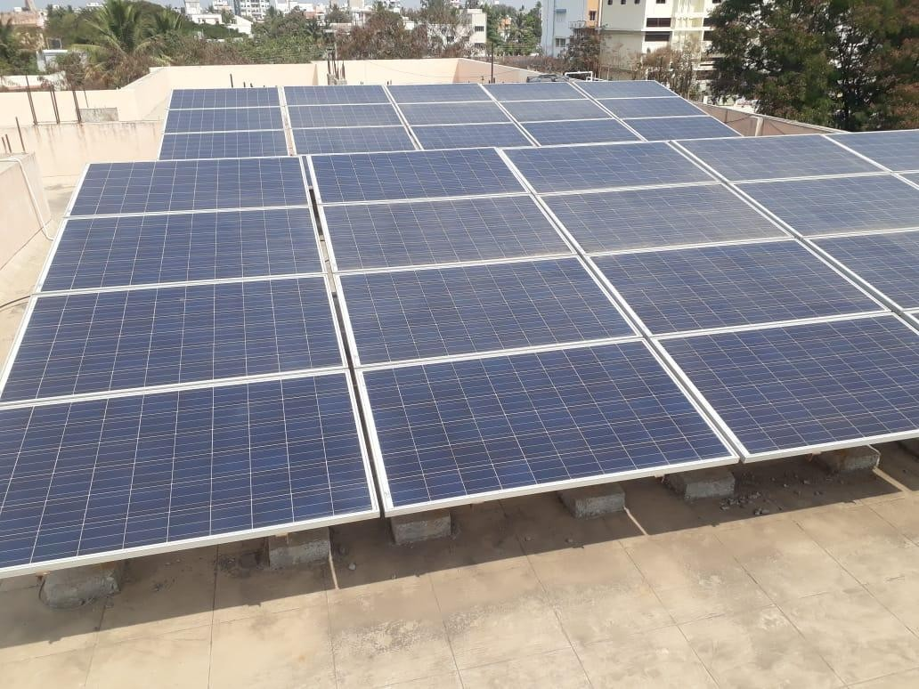

Energy Cost Reduction Measures (ECRMS):
- Replace conventional Fluorescent Lamps with CFLs/ power saver LEDs.
- Replace Indoor Tube lights/ bulbs with LEDs.
- Replace existing Tube Lights with LEDs

WATER AUDIT
Water audit addresses water consumption, water sources, irrigation, storm water, appliances and fixtures. A water audit is an on-site survey and assessment to determine and improve efficiency water use. In survey water used at toilets, laboratory, garden, as well as leakages and over flow of water from overhead tanks is also been evaluated.

Water Supply and its distribution –
The college depends on Solapur Municipal Corporation drinking water purpose. The college has installed R.O. system of pure water supply to students and staffs. The college has bore well, the water from this bore well is used for all non-drinking purpose in college. The college had made efficient water harvesting system. The details are as described below:

Drinking water facility and its distribution –
The drinking water is obtained from Solapur Municipal Corporation alternatively for three or four days and is stored in the 33000 liter tank located at ground level. Then this water is pumped to 2000 liter storage tank present at roof of building. Then this water is distributed to 750 liter tank for Reverse Osmosis process. The R.O. water is then flowed towards 50 liter storage tank from where it is made available to all stakeholders by pipe-line system. The portablity of R.O. water is confirmed from Ana Lab, Solapur.

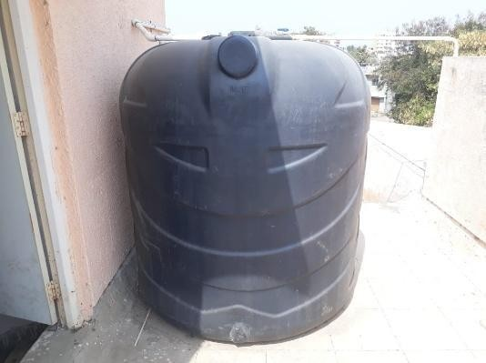
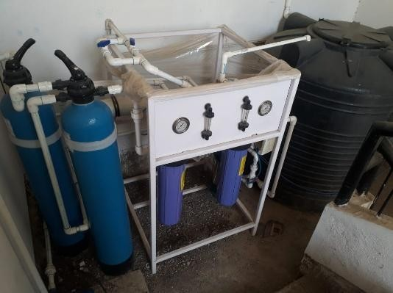

2000 Liters Drinking Water Storage Tank R.O. Unit

  - Non-drinking water facility and its distribution –
The non-drinking water for college is used from bore well system. The college has one active bore well within the campus. The water is pumped from this bore well to the two separate 2000 liters capacity storage tank. From this storage tank the water is supplied to laboratory,

office, gardening and latrine through pipe-line. The drip system is used in college for gardening purpose is provided with bore well water.
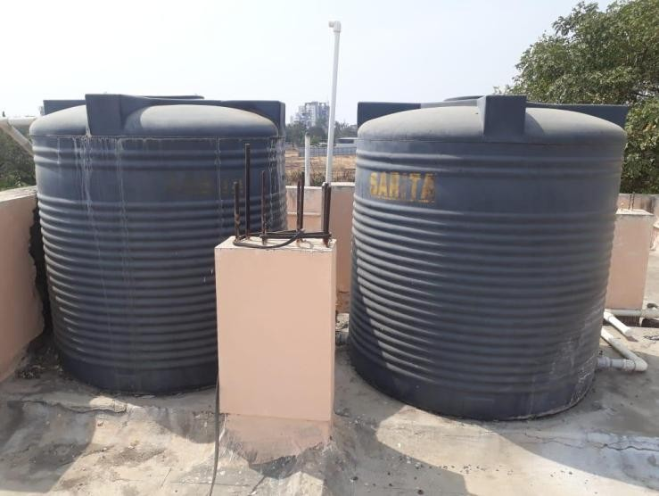

Non-drinking Water Storage Tank (each 2000 liter capacity)

- Water harvesting system –
College collects the roof rain water in barrels which is used as distilled water in laboratories. The remaining roof water is collected in water tank which is located at ground level. This water is then pumped out and used for gardening purpose. The college has rain water harvesting system located near the college ground. The water percolates from this harvesting system so, that ground water level will increase. The college soil has good percolation capacity, so that water flows from ground surface will easily percolated in soil.

Water usage –
The water is utilized in various units of college such as laboratories, office, toilets, garden etc. The overall water users and average water usage is described as below:

Drinking Water Usage :

Sr. No. | Components | Average No. Per day | Total of Average
1 | Students | 650 | 720
2 | Teaching Staff | 25 | 720

3 | Non Teaching Staff | 25
4 | Visitors | 20
Working Hour of College is 6 Hours. Average of 2 liters of water will be consumed by a person in 6 hours. Thus the total consumption of water by all components = 720 x 2 = 1420 liters on an average.

Non-drinking Water Usage :

Sr. No | Name of Unit | Average No. of Users per day | Daily Non-drinking Water Requirement  (liters) | Daily Water leakages  (liters)
01 | Biochemistry Lab | 50 | 100 | 00
02 | Bioscience Lab | 50 | 100 | 00
03 | Biotechnology Lab | 50 | 100 | 00
04 | PG Laboratory | 50 | 100 | 00
05 | Common Facility Centre | 40 | 20 | 00
06 | Office | 10 | 10 | 00
07 | Principal Cabin | 10 | 10 | 00
08 | Staff room | 25 | 10 | 00
09 | Toilets | 650 | 1000 | 02

Total Storage Capacity of Tanks: 4,000 Liters Daily water use in each department: 1,000 Liters

ENVIRONMENT AUDIT
The V. G. Shivdare College is located in Solapur city, Maharashtra, India. The Geographical position of the study area is with latitude 17.647500 and longitude 75.900110. The total area of campus is 3.28 acre with natural and cultivated habitat. The climate of study area is healthy, fresh moderately cool because lots of vegetation covers in the campus. The maximum area of campus is covered by plants, herbs, shrubs and lawn which increase aesthetic value of college.
Study region is divided into 4 zones according to area of campus Zone A: Parking area
Zone B: V. G. Shivdare College Zone C: Unique school area Zone D: Pharmacy College area
Total 17 species of trees, 28 species of shrubs, 11 species of herbs and 5 species of grasses were recorded. The study also records 10 species of reptiles, 11 species of birds, 25 species of insects including butterflies. Among reptiles, garden lizard, rock lizard and tree lizards are commonly distributed. 11 species of birds were recorded, in which, Sparrows, Parrot, Crows, woodpecker were common.

Concluding remark and recommendations:
Since the college has taken adequate measures to reduce the burden on the environment by anthropogenic activity. The audit conducted by internal audit team has found that the college tried to reduce the overall carbon foot-printing in all its possible way. The infrastructure of college reduces the use of electricity in college campus alternatively helped environment. The college worked on reduce, reuse and recycle strategy for the solid and liquid waste generated in college campus. The alternative energy source i.e. solar energy panel within campus and use of LED bulbs and LED tubes indicates the college approach towards the sustainability of environment. The college has good green carpet area covered by various trees, shrubs, grasses helps to maintain the biodiversity as a result within campus we can observe the different birds, insects, reptiles etc. This will provides the good environment for students, staffs and all stakeholders of college. The internal audit committee recommends the college to establish the oxygen park concept within the college campus.

DSTS MANDAL’S

V. G. SHIVDARE COLLEGE OF ARTS, COMMERCE AND SCIENCE, JULE SOLAPUR, SOLAPUR-413004



Audit Report on Energy – 2023-24 (Power Supply and Energy Utilization)

CONTENTS

Sr.  No | Particulars | Page No
1 | Auditing Committee | 25
2 | Certificate | 26
3 | Introduction | 27
4 | Audit report | 27
5 | Recommendations | 29

Energy audit committee

Name | Designation
Principal Dr. B. N. Kamble | Chairman
Mr. C. J. Dighe | External Auditor
Dr. A. B. Valsange | Internal Auditor  IQAC – Coordinator
Mr. C. P. Umrajkar | Coordinator
Mr. R. M. Agaje | Electrician
Mrs. N. Nagshetti | Member
Mr. S. P. Habbu | Member

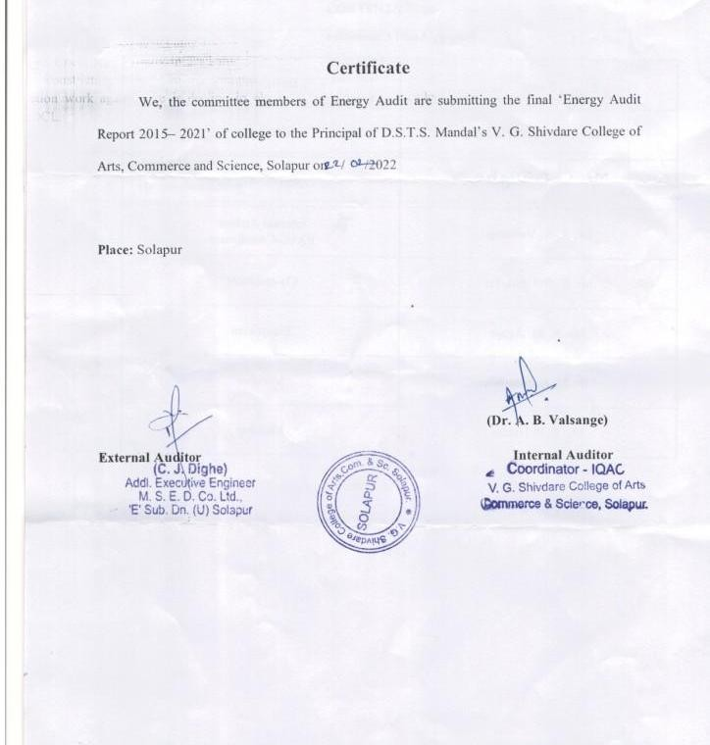

INTRODUCTION:
Energy audit covers the power supply and energy utilization in any organization. It is performed by enquiry, inspection, testing and verification. At our college level, we have established the Energy Audit Committee for analyzing energy utilization in our campus.

AUDIT REPORT:
Power Supply:
The college depends on the services of Maharashtra State Electricity Distribution Co. Ltd. (MSEDCL) for electricity. The power coming from MSEDCL goes through the electrical panel which acts as the main switchboard that distributes the electricity needs within college. This can be for lights, equipments, and other devices used within college campus. The college also generates electricity by solar energy system which is wheeled to Grid.
There are 4 different types of electrical panels – the main breaker panel, fuse boxes, main lug panels, and subpanels. The main breaker panel is the mother of all the panels. It regulates the circuit breakers and the electricity consumption within college. Fuse boxes are made up of small fuses which are designed to prevent overloading within your circuits. Main lug panels are comprised of line wires that run into lugs eliminating the need for the main breaker. Subpanels are electrical panels that get their energy from the main panel through a particular circuit. They allow you to control the electrical consumption of different college sections. At energy outage the college obtain energy from generator for that the manual change over switch is available with college. All electrical panels are enclosed in electrical cabinets. All these electrical panels are working and safety measures are followed by college.
From these electrical panels the power is transferred to various sections of college via heat resistive PVC coated electrical cable through casing. At various points the Miniature Circuit Breaker (MCB) are installed by college. It automatically switches OFF electrical circuit during any abnormal condition in the electrical network such as overload & short circuit conditions. The electrical switch boards are installed at all sections of college to switch on and off the power supply needed for the unit.
All these installations are maintained in well manner and are safe to use.

Electrical Panel in Main Breaker Panel Solar Electricity Generation System Safety Cabinet
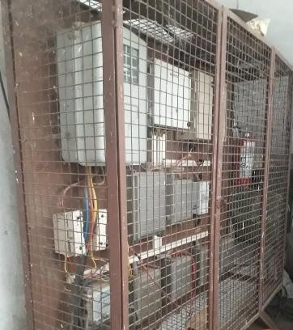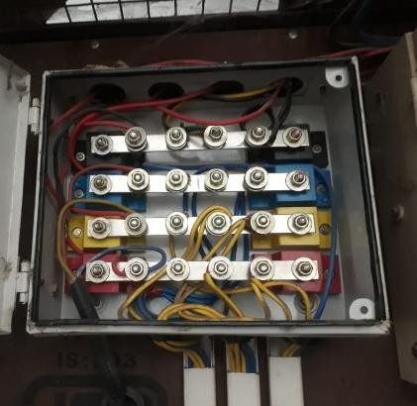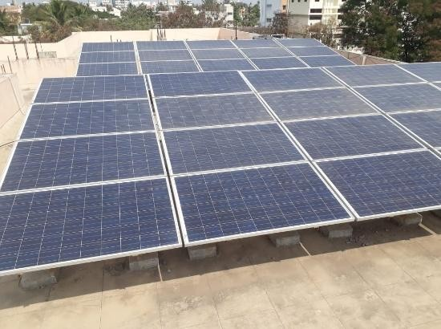
Solar system (Potential & savings):
In the campus of V. G. Shivdare College of Arts, Commerce and Science the management has installed solar panels with capacity of 10 KVA. The unit started working from 01/09/2016. The electrical energy generated through these solar panels are wheeled to the Grid.

The Comparative Statements of Energy Utilization & Energy Savings details are given below:
2015-16 |  | 2016-17 |  | 2017-18 |  | 2018-19 |  | 2019-20 |  | 2020-21 |  | 2021-22
Mont h | Units  Cons- umed | Mon th | Unit s Con  -  sum ed | Mon th | Unit s Con  -  sum ed | Mon th | Unit s Con  -  sum ed | Mon th | Unit s Con  -  sum ed | Mon th | Unit s Con  -  sum ed | Mon th | Unit s Con  -  sum ed
Jun-15 | 1042 | Jun-  16 | 910 | Jun-  17 | 0 | Jun-  18 | 511 | Jun-  19 | 306 | Jun- 20 | 86 | Jun- 21 | 0
Jul-15 | 1117 | Jul-  16 | 1059 | Jul-  17 | 0 | Jul-  18 | 152 | Jul-  19 | 0 | Jul- 20 | 554 | Jul- 21 | 87
Aug- 15 | 1626 | Aug-  16 | 1006 | Aug-  17 | 491 | Aug-  18 | 805 | Aug-  19 | 497 | Aug- 20 | 175 | Aug- 21 | 291
Sep- 15 | 1683 | Sep-  16 | 0 | Sep-  17 | 0 | Sep-  18 | 584 | Sep-  19 | 502 | Sep- 20 | 374 | Sep- 21 | 454
Oct-15 | 1685 | Oct-  16 | 351 | Oct-  17 | 47 | Oct-  18 | 443 | Oct-  19 | 1269 | Oct- 20 | 632 | Oct- 21 | 575
Nov- 15 | 1622 | Nov-  16 | 0 | Nov-  17 | 1311 | Nov-  18 | 0 | Nov-  19 | 858 | Nov- 20 | 537 | Nov- 21 | 330
Dec- 15 | 1085 | Dec-  16 | 0 | Dec-  17 | 1137 | Dec-  18 | 111 | Dec-  19 | 1125 | Dec- 20 | 177 | Dec- 21 | 635
Jan-16 | 1456 | Jan-  17 | 0 | Jan-  18 | 366 | Jan-  19 | 0 | Jan-  20 | 1283 | Jan- 21 | 377 | Jan- 22 | 474
Feb- | 1431 | Feb- | 0 | Feb- | 446 | Feb- | 0 | Feb- | 1199 | Feb- |  | Feb- | 432

16 |  | 17 |  | 18 |  | 19 |  | 20 |  | 21 | 462 | 22
Mar- 16 | 1727 | Mar-  17 | 0 | Mar-  18 | 730 | Mar-  19 | 378 | Mar-  20 | 864 | Mar- 21 | 473 | Mar- 22 | 361
Apr- 16 | 1253 | Apr-  17 | 126 | Apr-  18 | 534 | Apr-  19 | 742 | Apr-  20 | 864 | Apr- 21 | 502 | Apr- 22 | 695
May- 16 | 1137 | May  -17 | 0 | May  -18 | 158 | May  -19 | 439 | May  -20 | 86 | May  -21 | 148 | May  -22 | 1317
Total | 16864 |  | 3452 |  | 5220 |  | 4165 |  | 8853 |  | 4497 |  | 5651
Avera ge per  month | 1405.  33 |  | 287.  67 |  | 435 |  | 347.  08 |  | 737.  75 |  | 374.  75 |  | 470.  91

Before September 2016, college was completely depended on MSEDCL for electricity. After installation of solar system which is wheeled to grid in two way. The average electricity consumed by the college during academic year 2015-16 is 1405 units per month obtained from MSEDCL. Then there is decline in the requirement of electricity from MSEDCL as the college has started generating its own electricity from solar system. The sharp incline in requirement of electricity in academic year 2019-20 is due to the internal renovation and new constriction work at college campus which requires more electricity. After this construction work, again there is decline in electricity requirement in college campus from MSEDCL.

Recommendations:
Precaution to be taken for the Energy Cost Reduction Measures (ECRMS):
- Replace conventional Fluorescent Lamps with CFLs/ power saver LEDs.
- Replace Indoor Tube lights/ bulbs with LEDs.
- Replace existing Tube Lights with LEDs

Green campus initiatives
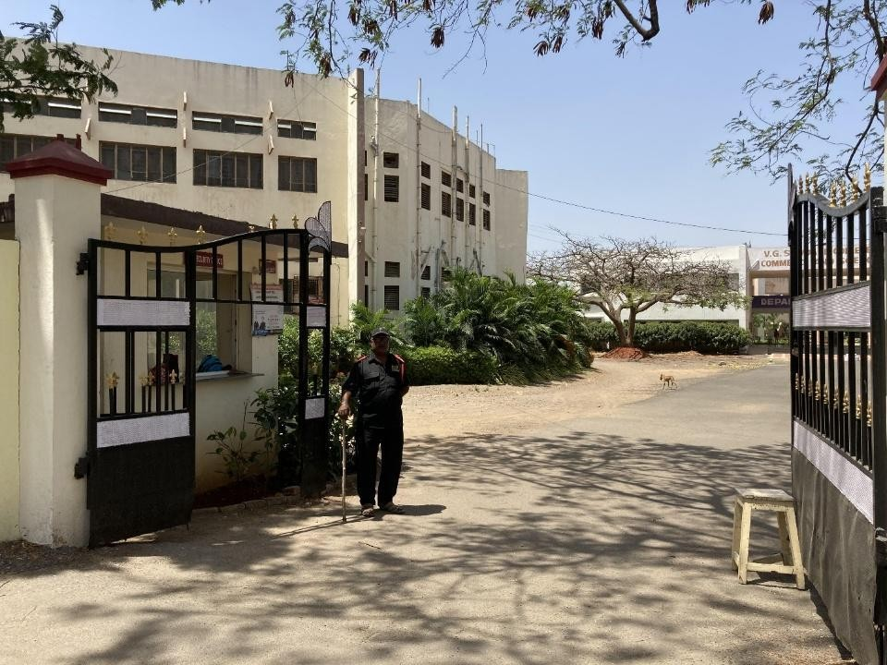
Restricted entry of automobiles

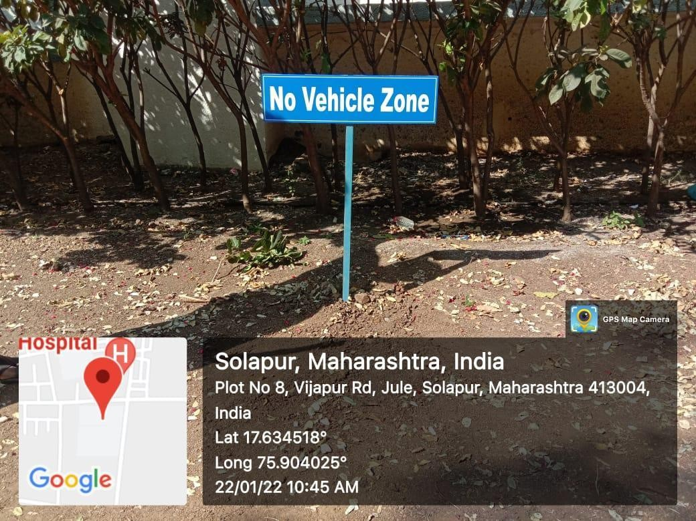
No vehicle zone
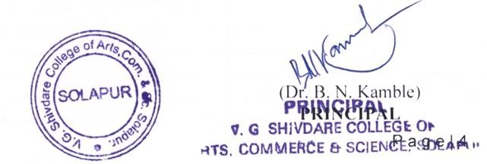

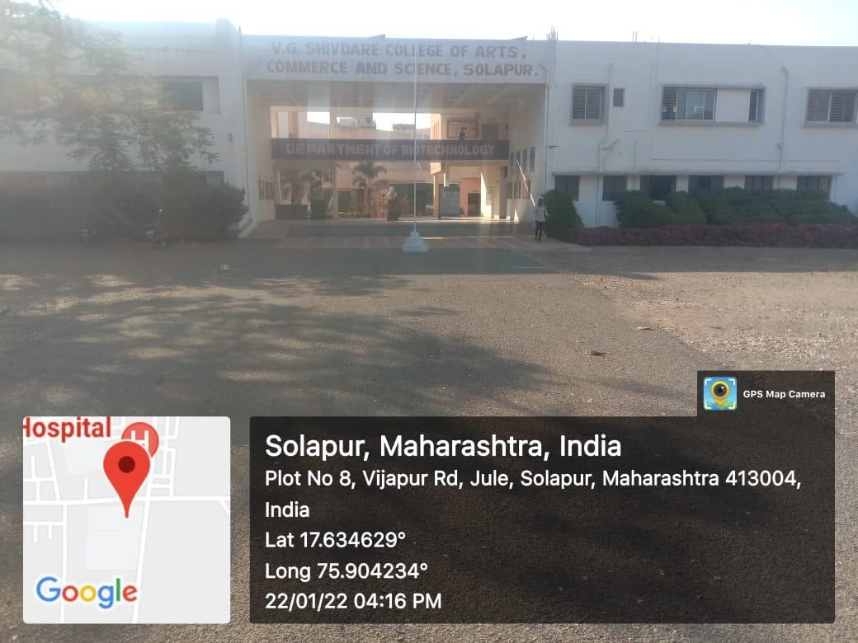

Pedestrian friendly pathways

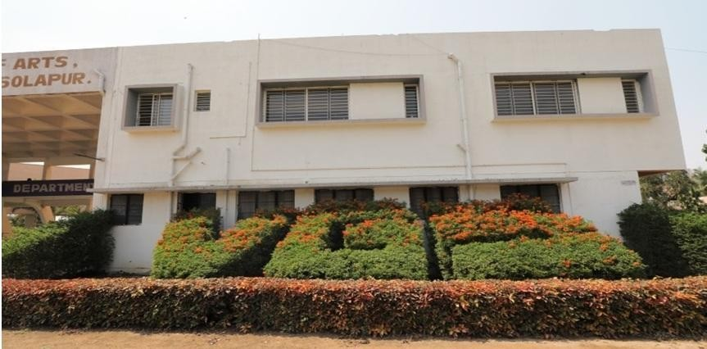

Landscaping with trees and plants - Greenery at College Front

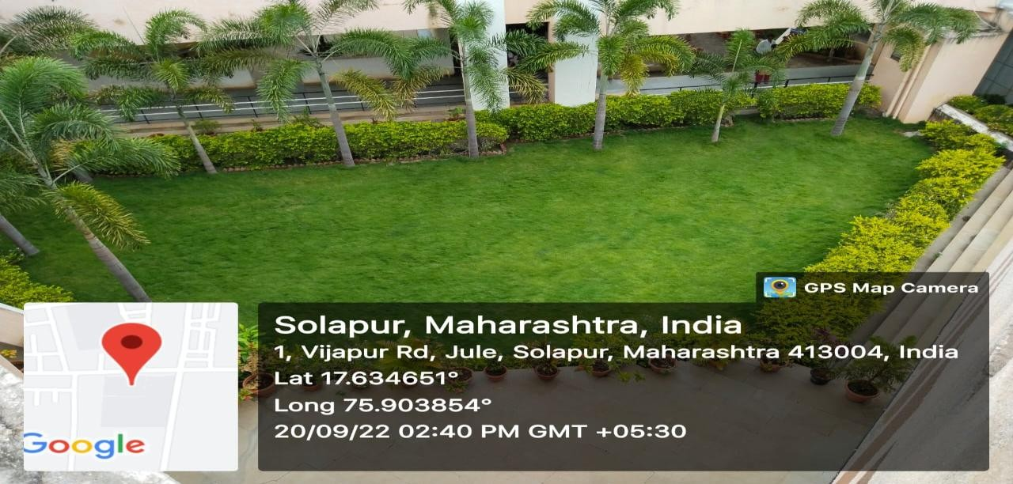
Greenery at College Entry

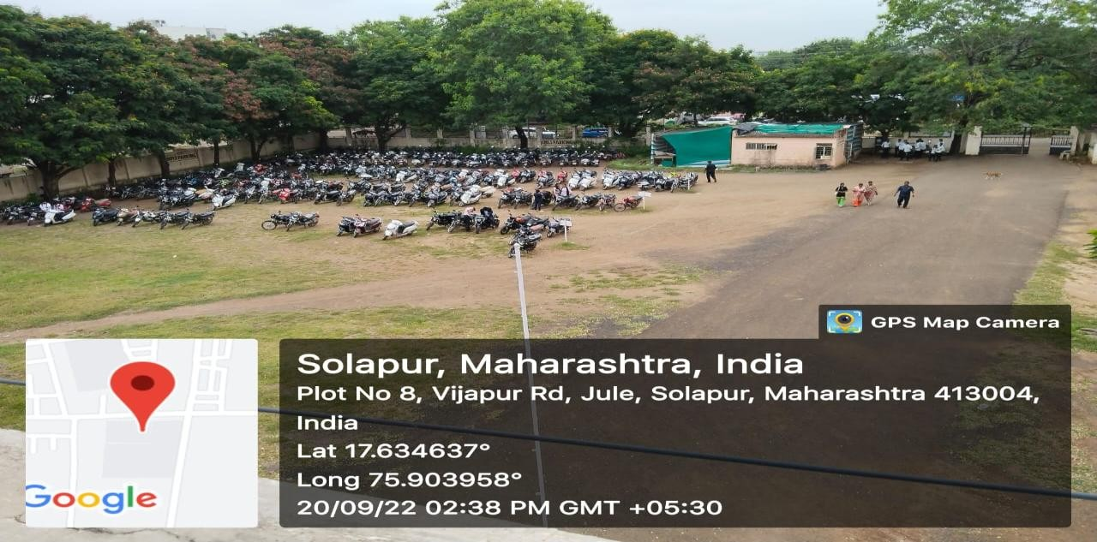

Plants at Parking Area
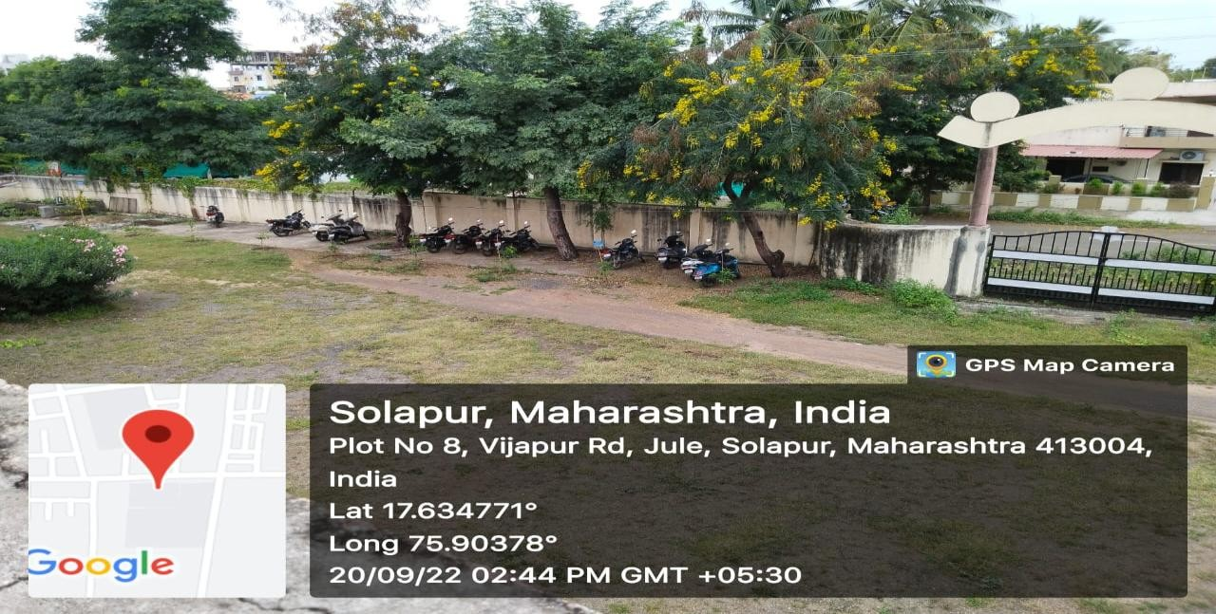
Plantation near wall compound of college

Tree plantation data

Year | No. of plants planted | No. of plants survived
2017-18 | 41 trees | 35
2018-19 | 650 shrubs | 650
2019-20 | 430 shrubs | 430
2020-21 | 342 shrubs | 342
2021-22 | 200 trees | 200

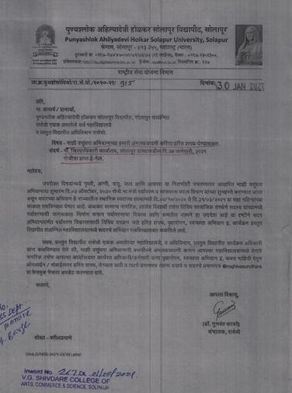

Letter from P.A.H. Solapur University to the institute regarding tree plantation program in collaboration with Solapur municipal corporation

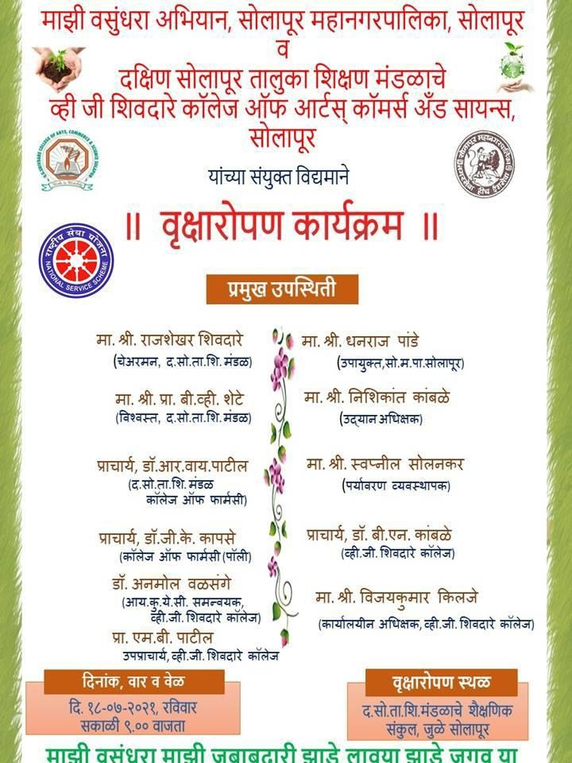

Tree plantation program schedule 18-07-21

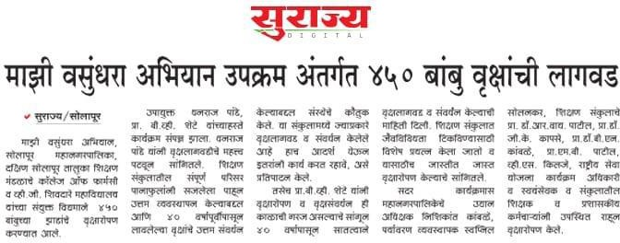

News regarding Tree plantation program

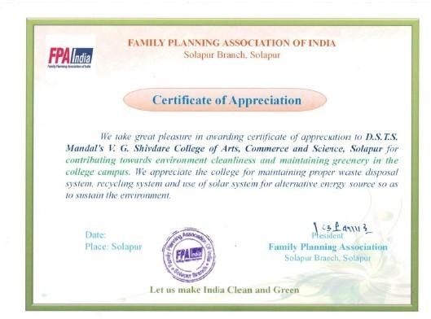Certificate of appreciation to institute for contribution towards environment cleanliness and greenery in campus

Beyond the campus environmental promotion activities
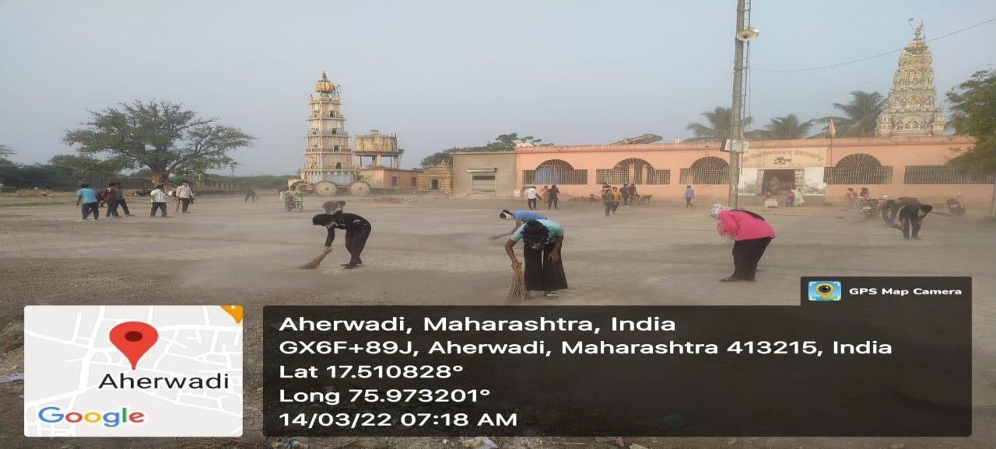
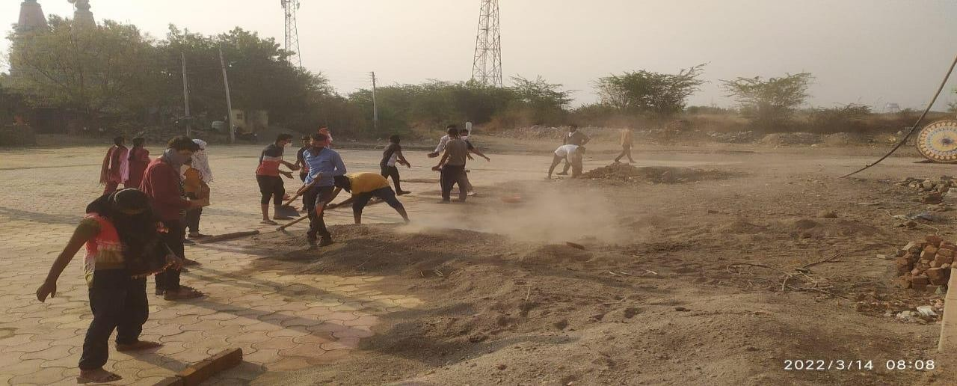

Clean environment promotion by NSS students at Aherwadi 14-03-22

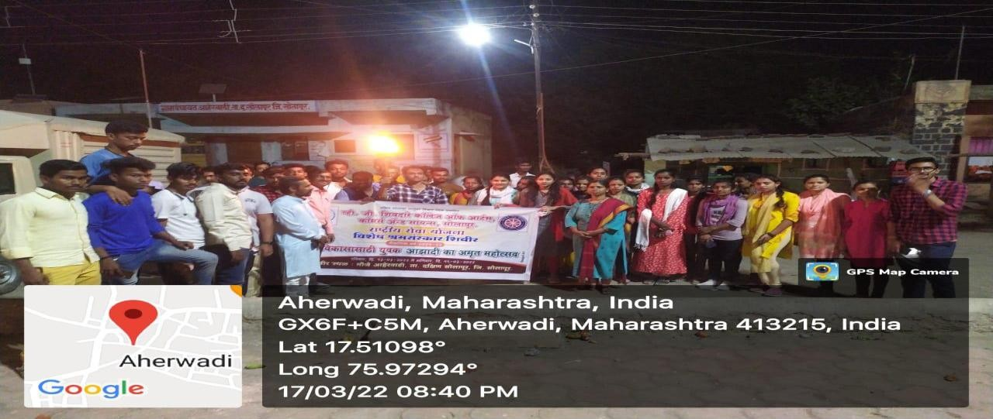
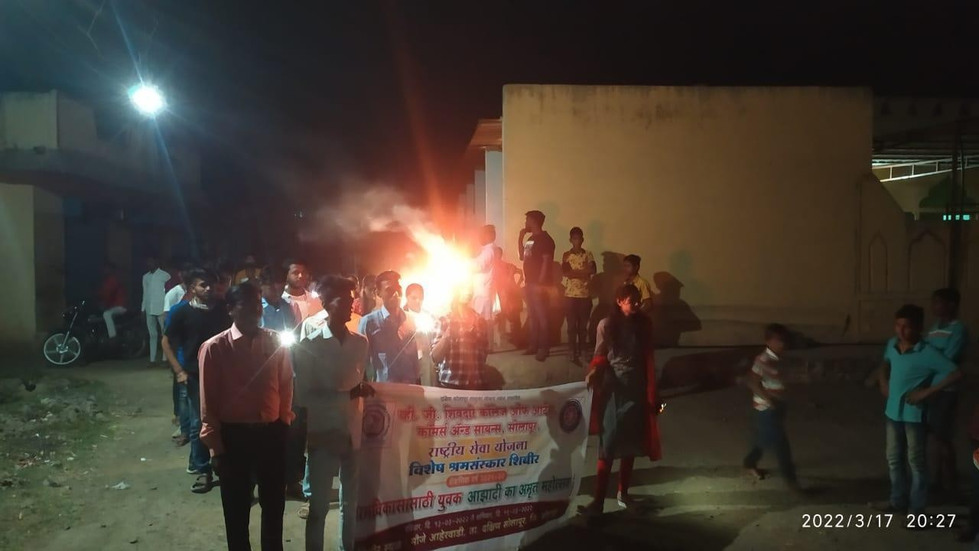

Rally at aherwadi village (clean environment promotion) by NSS students 17-03-22

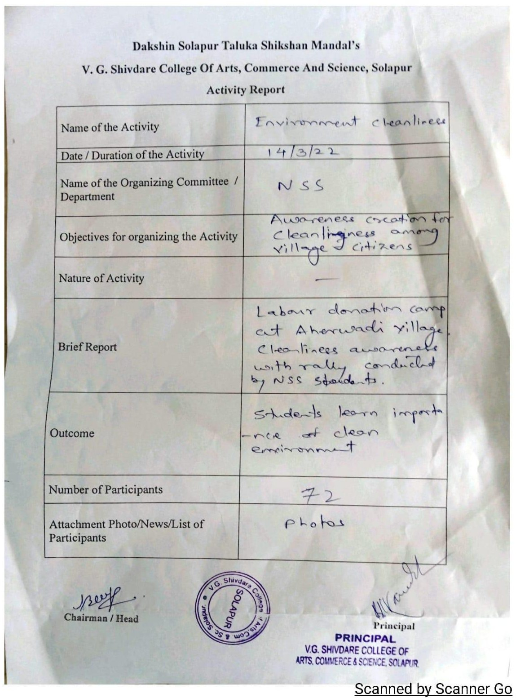

Activity report - clean environment promotion by NSS students

Cycle rally for pollution free environment promotion 08-06-22
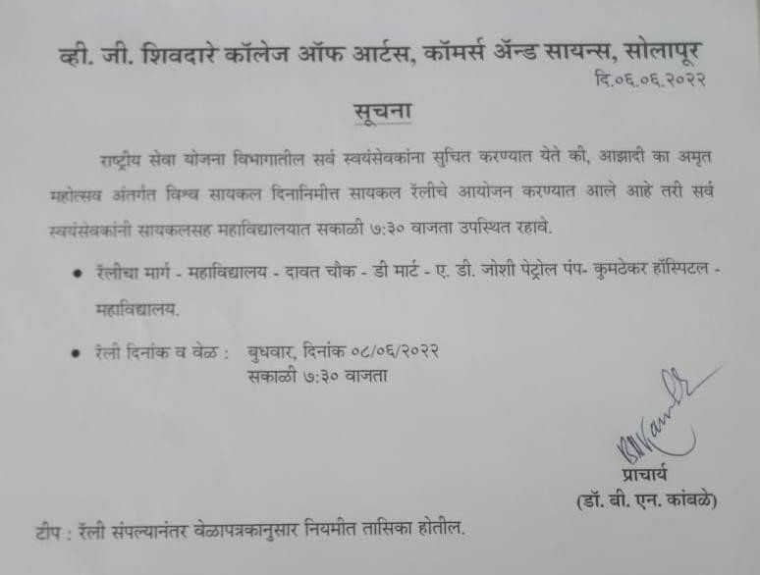

Notice

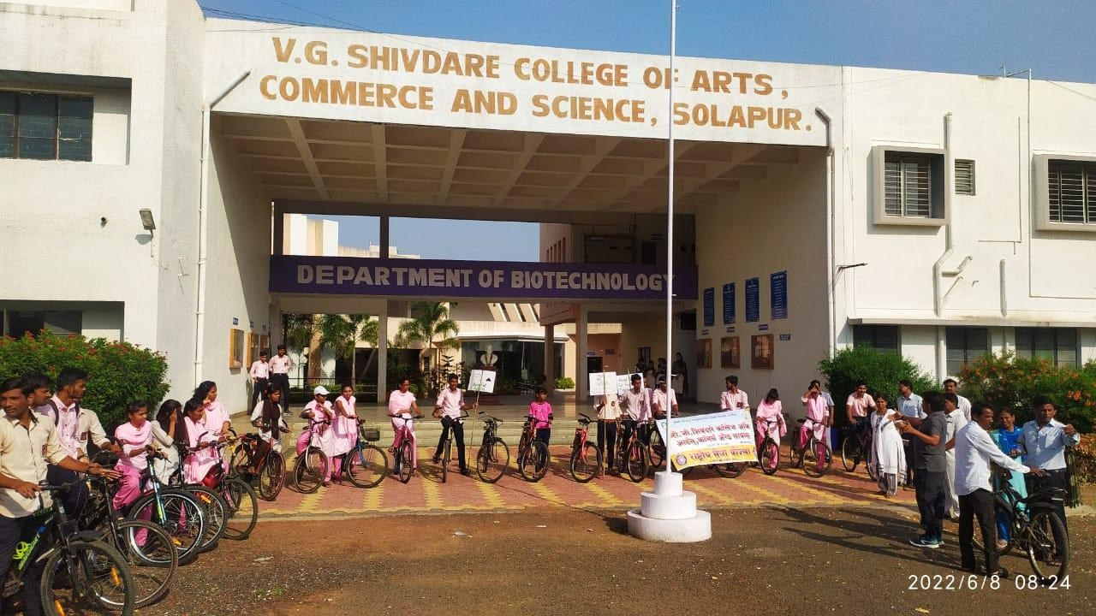

Students participating in cycle rally

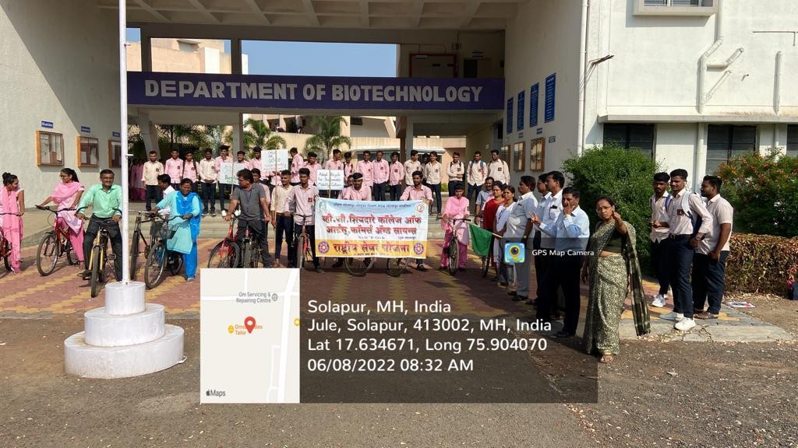

Start of Cycle Rally at college

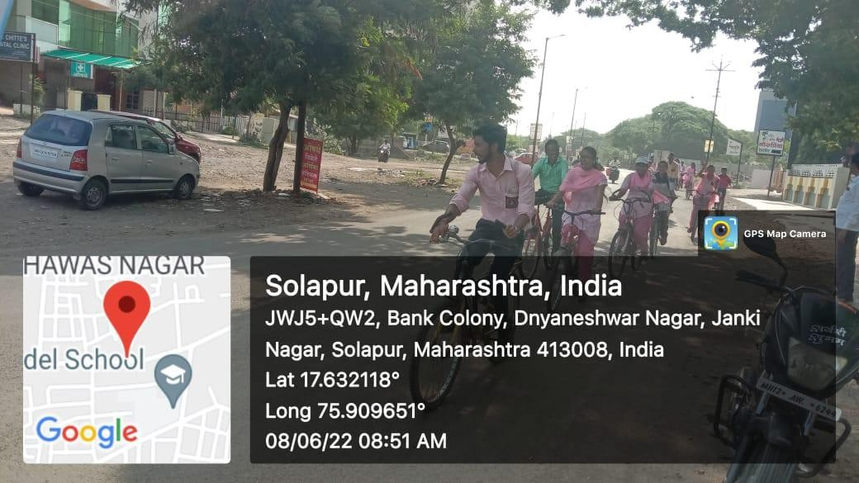

Cycle rally - Around the city

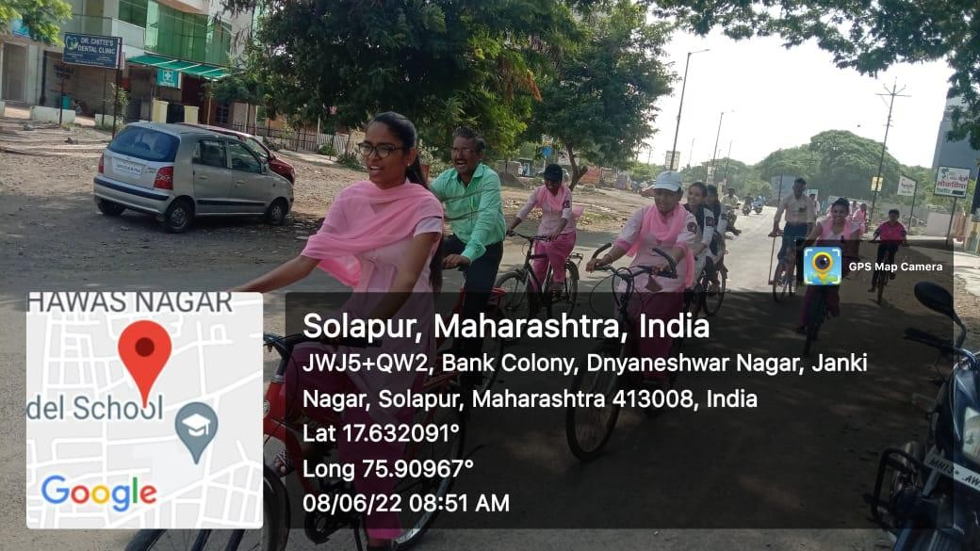

Cycle rally - Around the city

