3.3.3 Number of books and chapters in edited volumes/books published and papers published in national/ international conference proceedings per teacher during year
Sl. No. | Name of the teacher | Title of the paper | Title of the proceedings of the conference | Name of the conference | National / International | Year of publication | ISBN/ISSN number of the proceeding | Affiliating Institute at the time of publication | Name of the publisher
1 | Dr. Subhada Upase | "Bharatiya Samaj Sanskruti ani Striwad" | Bhasha, Sahitya, Sanskruti : Sahasambhandh V Prabhav | Bhasha, Sahitya, Sanskruti : Sahasambhandh V Prabhav | International | 05th Feb 2024 | ISSN : 573X | P.A.H. Solapur University Solapur | Tifan
2 | Gopika Manjunath | Ethnobotanical and Critical Appraisal Studies in Tithonia Species | Scientific Approaches For Sustainable Environment | Scientific Approaches For Sustainable Environment | National | Dec-23 | 978-93-93789-57-0 LSPP 03 | University of Mumbai
3 | Dr. Subhada Upase | " Shaikshanik Bank Of Credit (ABC) Che navin niyam" | Implimentation of NEP-2020 | Implementation of NEP-2020 | National | 28th Feb 2024 | ISSN: 978-81-971-567 Impact Factor 5.5 | P.A.H. Solapur University Solapur | Sanskruti Publication Latur
4 | Dr. Anita Birajdar | "NEP 2020 Samsya, Awhane, Sandhi" | Implimentation of NEP-2020 | Implementation of NEP-2020 | National | 28th Feb 2024 | ISSN : 978-81-971-567 Impact Factor 5.5 | P.A.H. Solapur University Solapur | Sanskruti Publication Latur

International Paper published By Dr. Subhada Upase – 05-02-2024
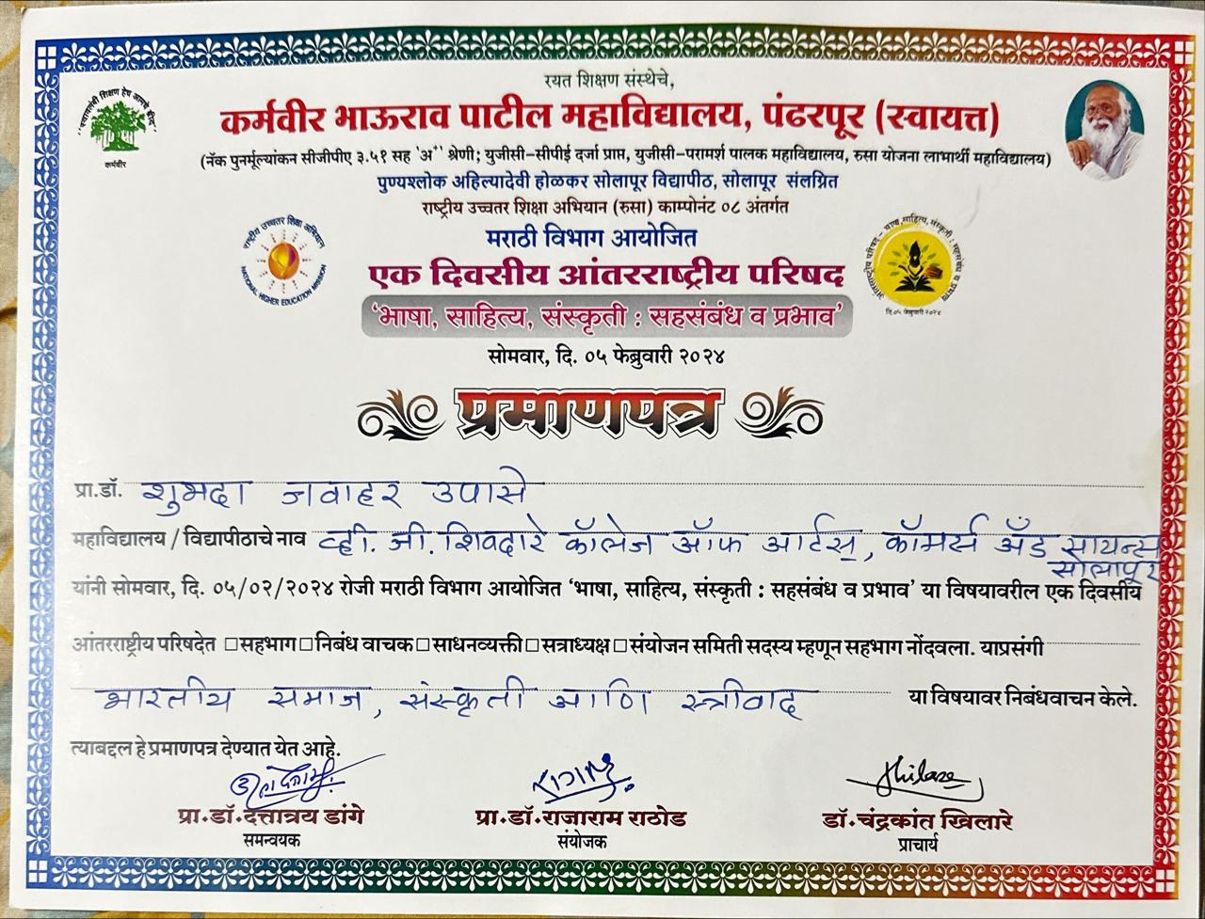

National Paper Published By Gopika Manjunath Dec 2023
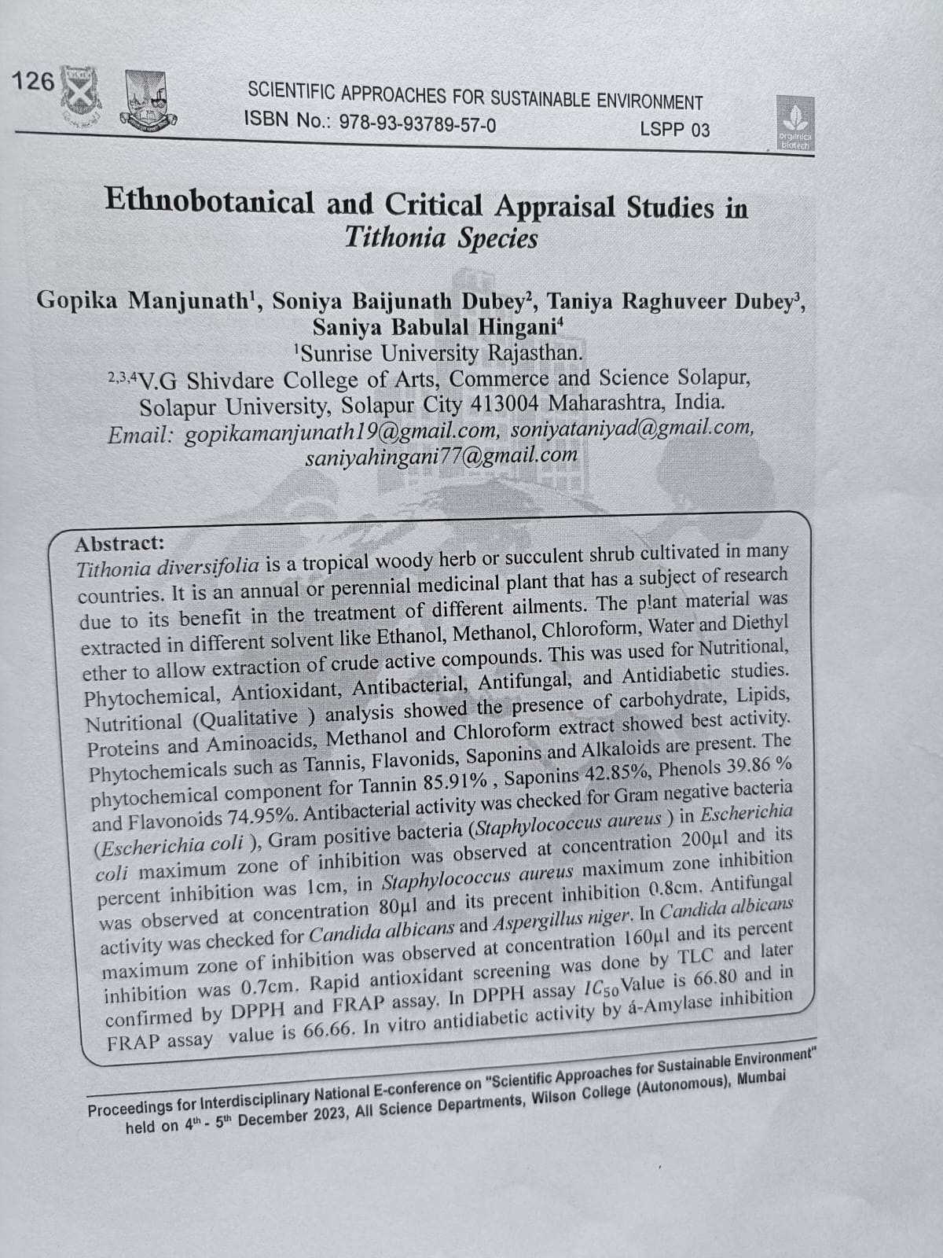

National Paper Published By Dr. Subhada Upase 28th February 2024
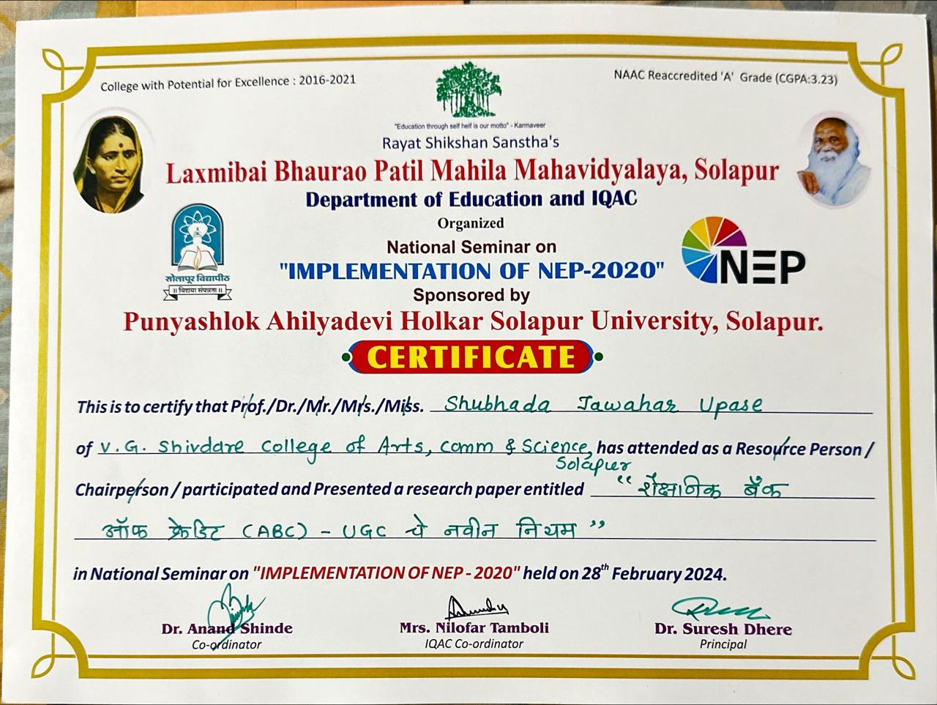

National Paper Published By Dr. Anita Birajdar 28th February 2024
