2.3.1 - Student centric methods, such as experiential learning, participative learning and problem solving methodologies are used for enhancing learning experiences
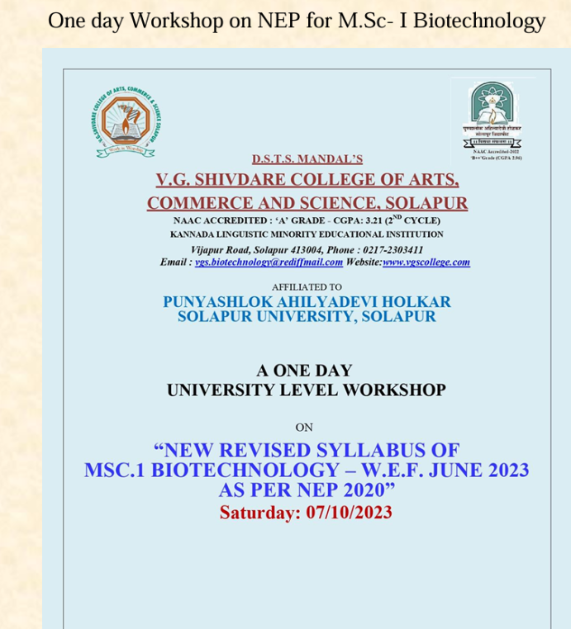

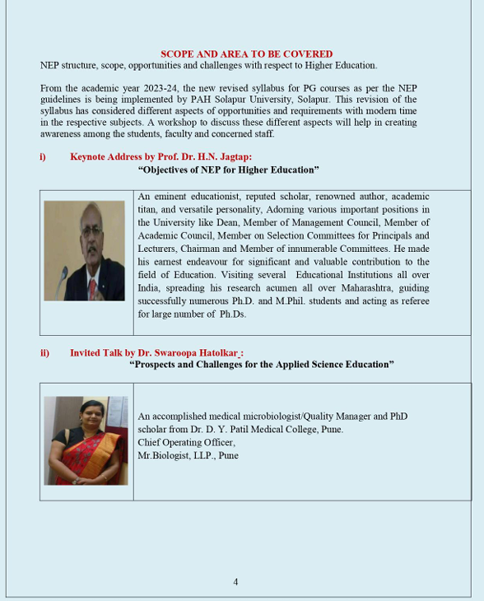

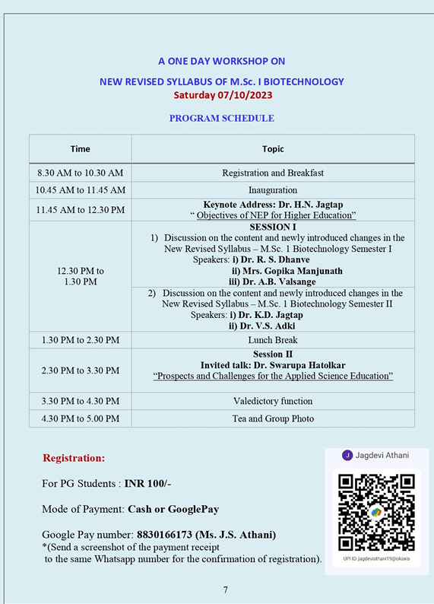

2.3.1 - Student centric methods, such as experiential learning, participative learning and problem solving methodologies are used for enhancing learning experiences
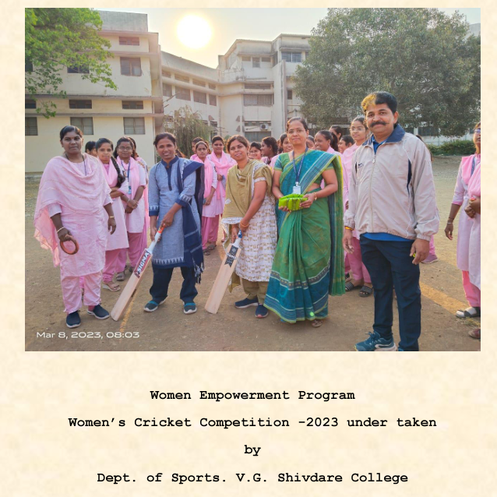
Women Cricket training programme

2.3.1 - Student centric methods, such as experiential learning, participative learning and problem solving methodologies are used for enhancing learning experiences
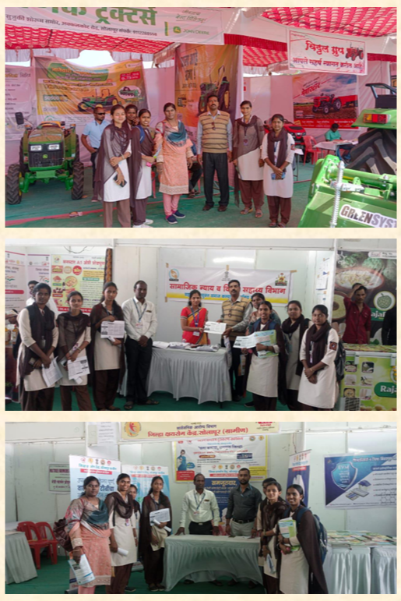

2.3.1 - Student centric methods, such as experiential learning, participative learning and problem solving methodologies are used for enhancing learning experiences

