CRITERION I
  - Curricular planning and implementation
    - and 1.1.2

Master Time Table - Bachelor of Arts (2023-24)
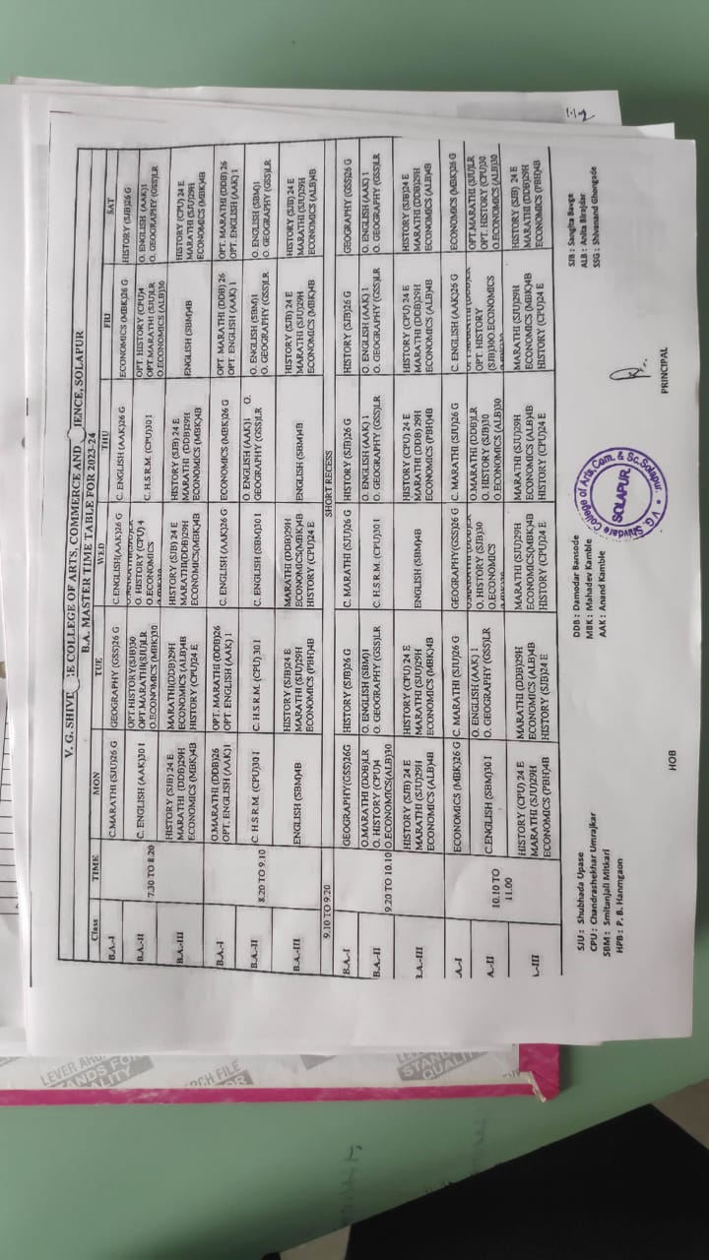

Time Table (2023-24) B.Sc. - I Biotechnology
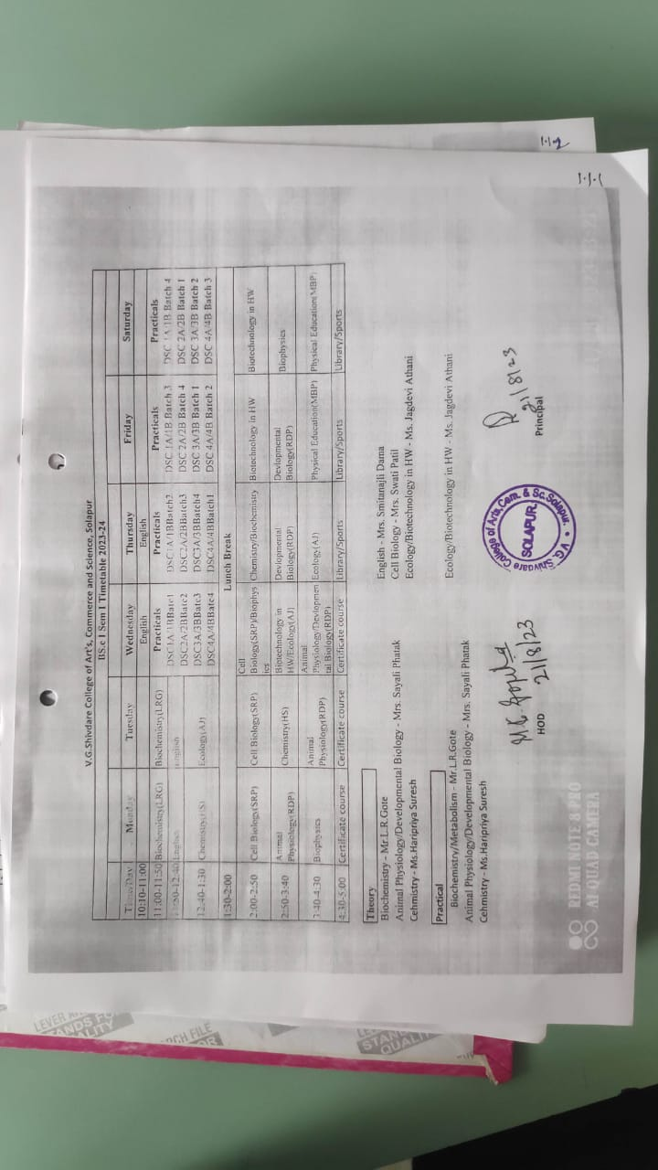

Time Table (2023-24) B.A. - II
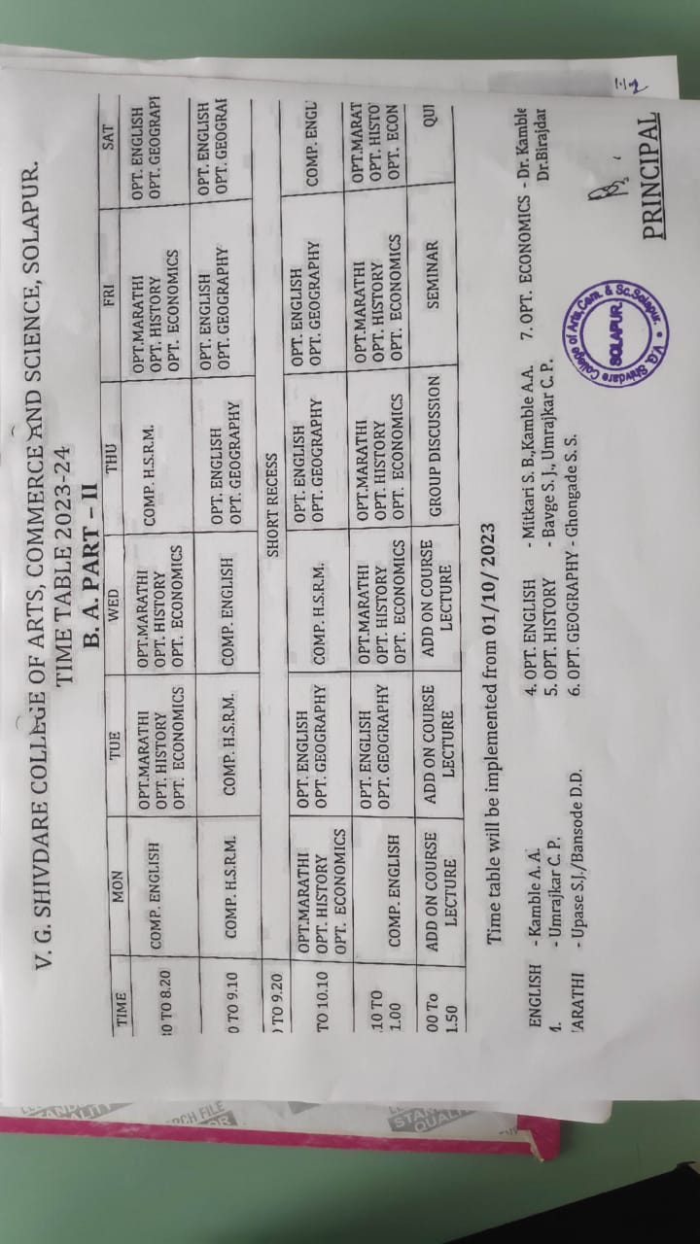
Time Table (2023-24) B.Com. - III
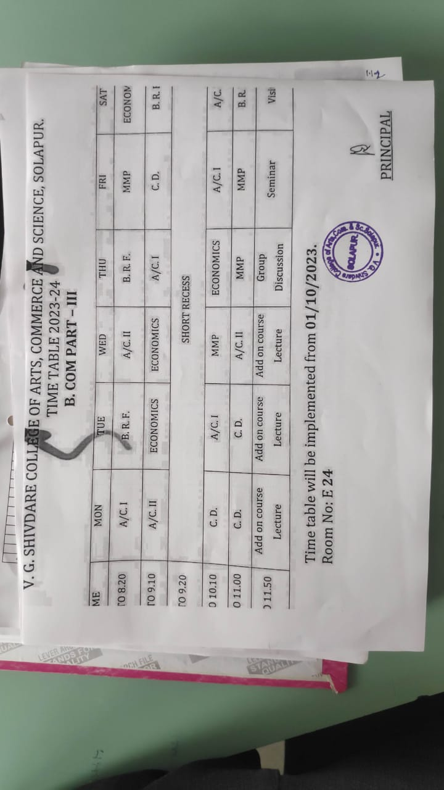

Teaching Plan (2023-24) BSc-II Biotechnology
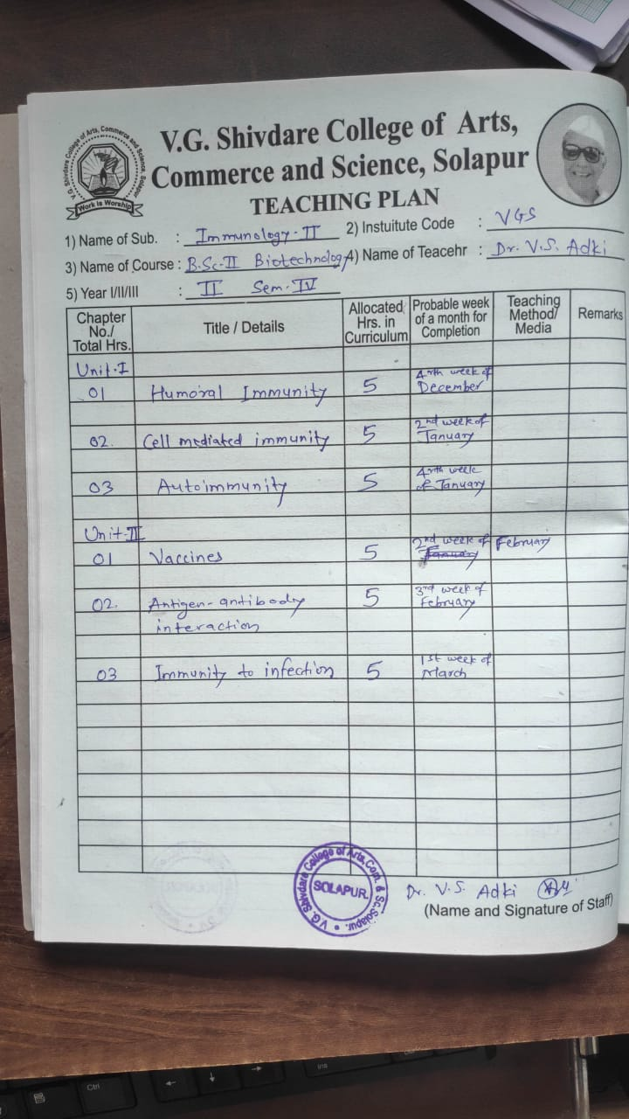

Teaching Plan (2023-24) B.Com II
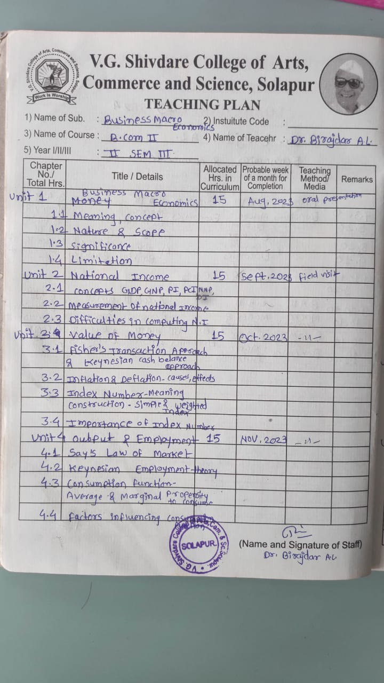

Teaching Plan (2023-24) B.A. II
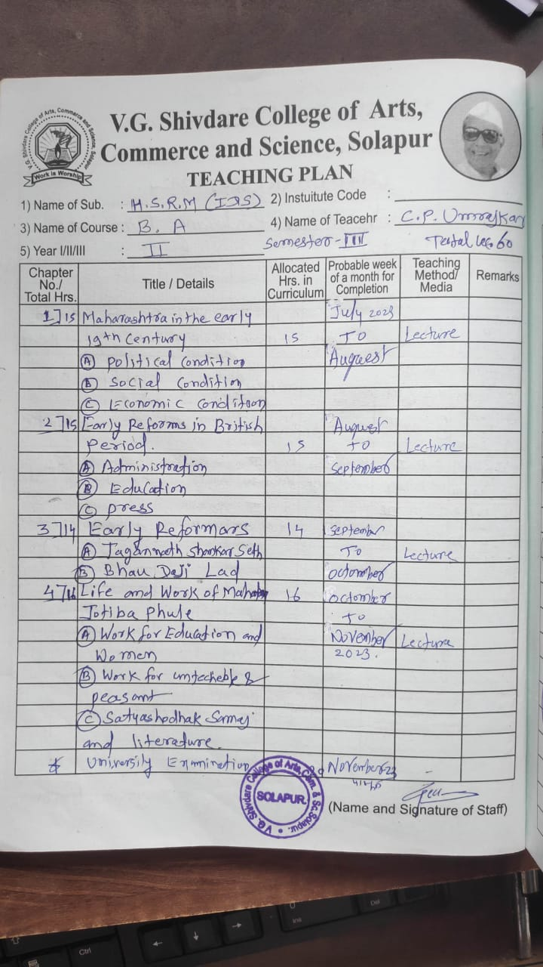

Syllabus completion (2023-24) B.Sc.-II
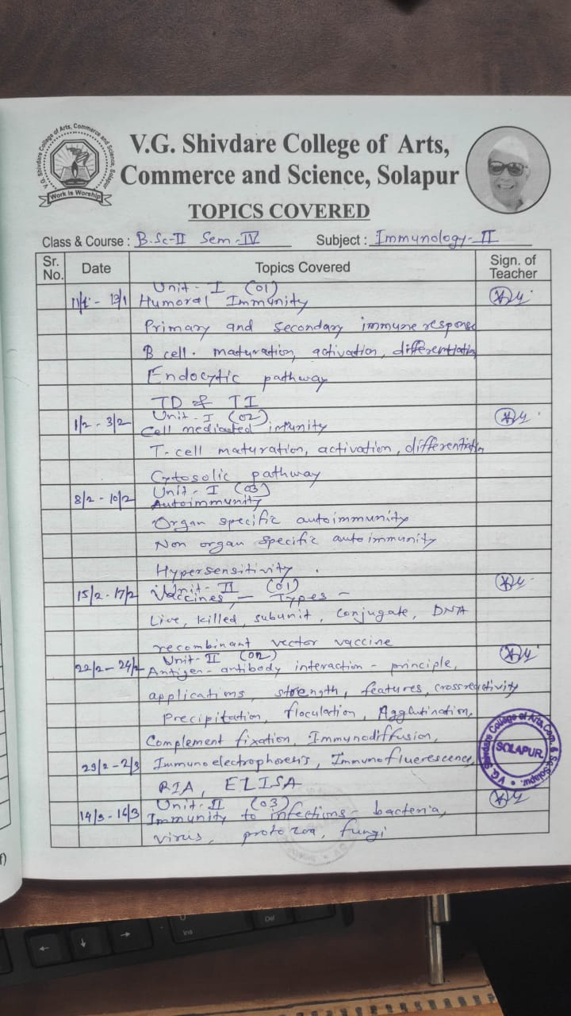

Syllabus completion (2023-24) B.A. - II
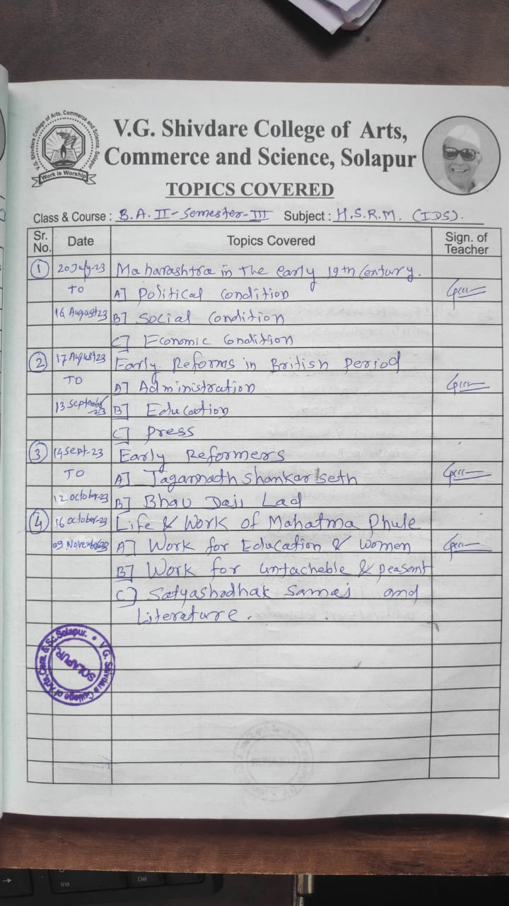

Syllabus completion (2023-24) B.Com - II

Students’ Attendance (2023-24) B.Sc. - II Biotechnology
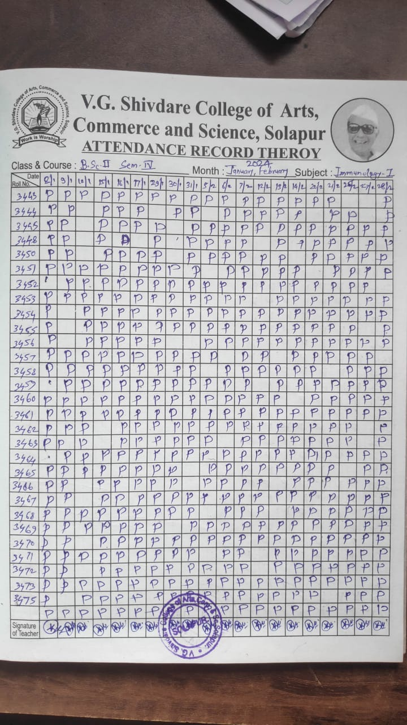

Students’ Attendance (2023-24) B.A. - II

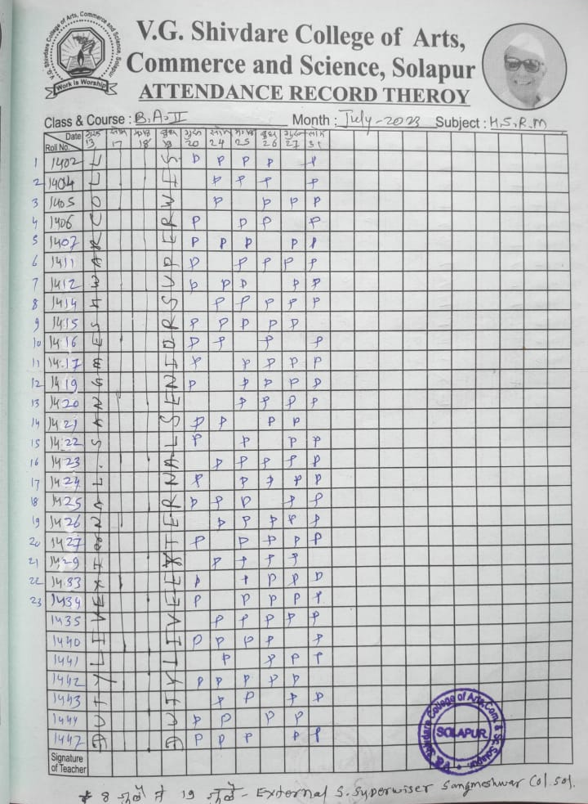
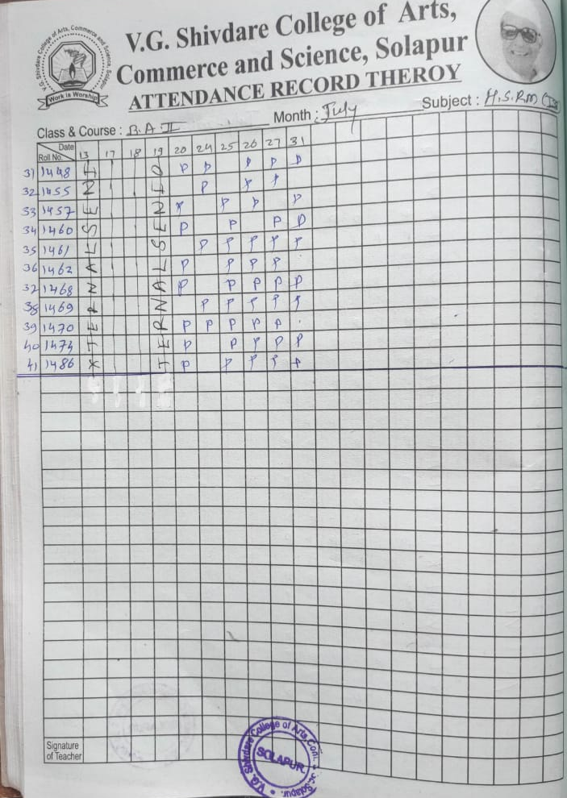

Students’ Attendance (2023-24) B.Com. - II

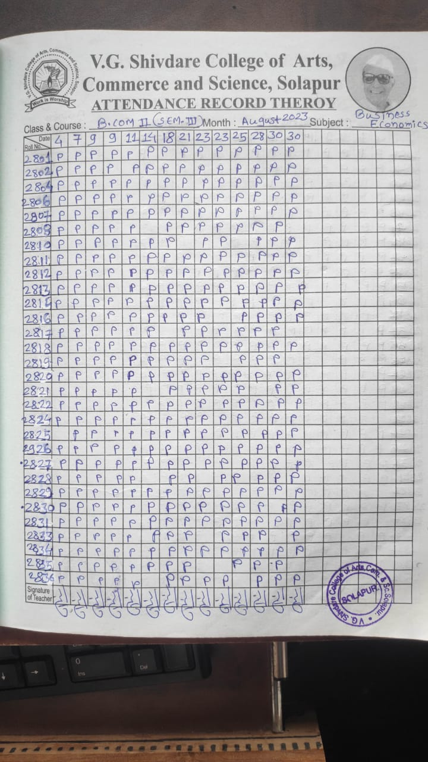

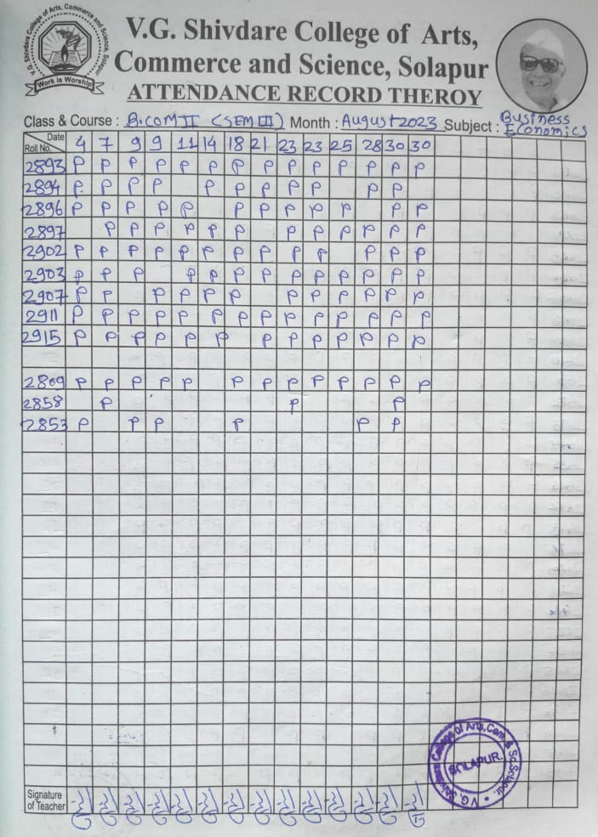

Internal Exam Time Table (2023-24)

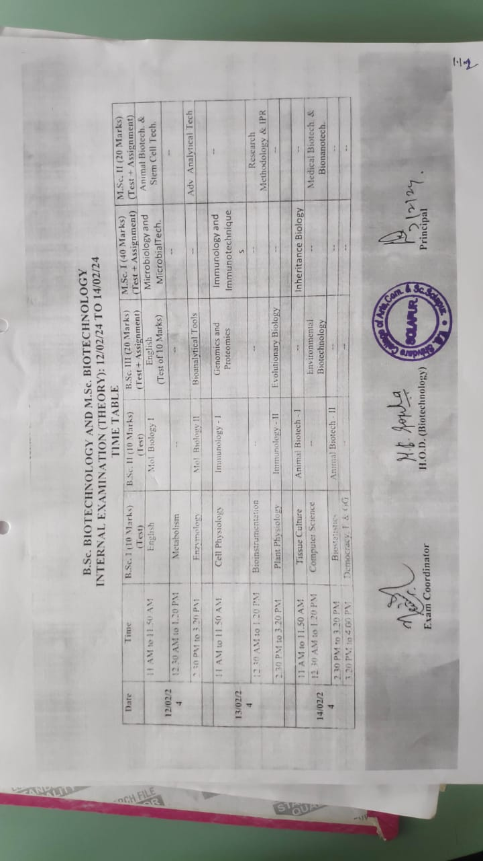

B.Sc.-II Biotechnology students opting Environmental Studies

